

University Admission Management System

Name | ID | Contribution
Sheikh Rubaeid Sanjid | 21-45844-3 | (33.34%)  Query Writing, Scenario Description, Normalization
Abdullah Al Faisal | 21-45872-3 | (33.33% )  UI Interface, Table Creation, Data Insertion
Wasifur Rahaman Chowdhury Alvi | 21-45856-3 | (33.33%)  ER Diagram,  Normalization, Table Creation

Course Name: Advance Database Management System
Section: A

Date of Submission: May 5, 2025

Introduction:
The University Admission Management System is a project that aims to make the university admission process easier and more efficient. It will help students apply for different programs, submit their personal and academic information, and check the status of their applications. At the same time, it will help university staff manage all the student applications in a smooth and organized way. This system will be built using a database that stores all important data, such as student details, application forms, program offerings, and admission results. The system goal is to reduce the amount of manual work needed, make fewer mistakes while admission, and speed up the admission process. Some Key features of the system are:
- An online application form for students to fill out and submit.
- Storing all student and program data in a safe and organized database.
- Generating reports to check student applications.
- Allowing students to see the status of their applications.
- An admin panel for university staff to review and approve applications.
By using this system, both students and staff will benefit from a more efficient and reliable admission process, with easy access to data and better communication throughout the whole process.


User Interface planning:
Figure: Landing Page


Figure: Signup Page


Figure: Login Page

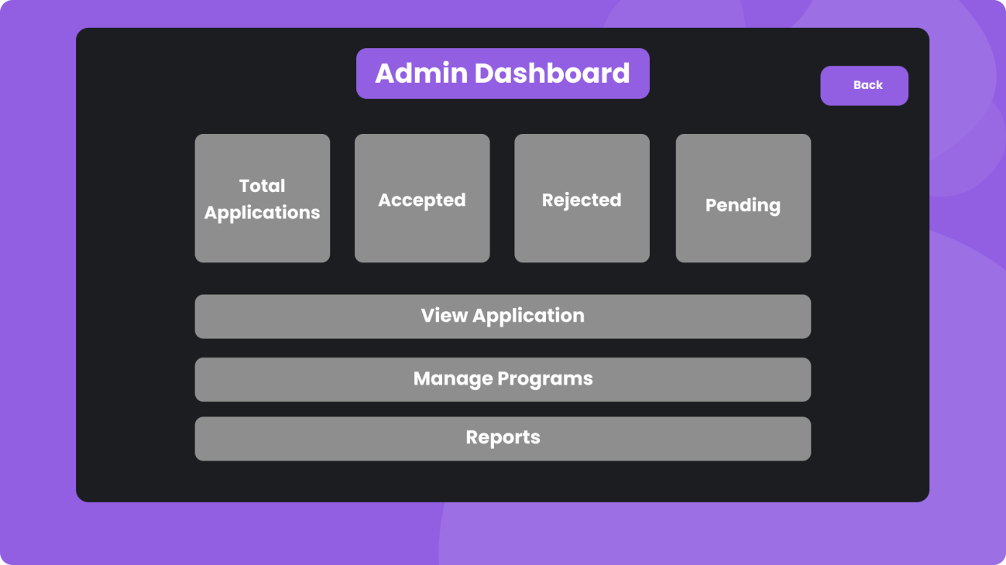
Figure: Admin Panel Page

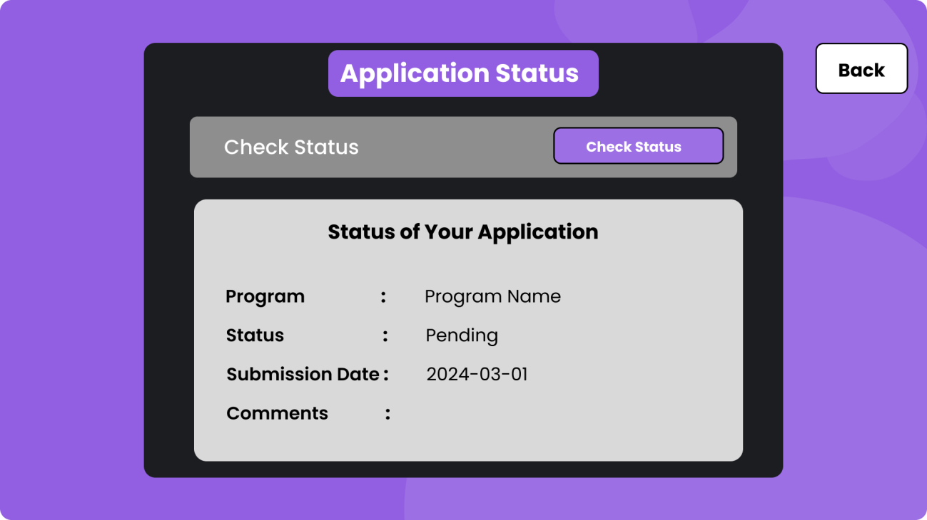
Figure: Application Status Page

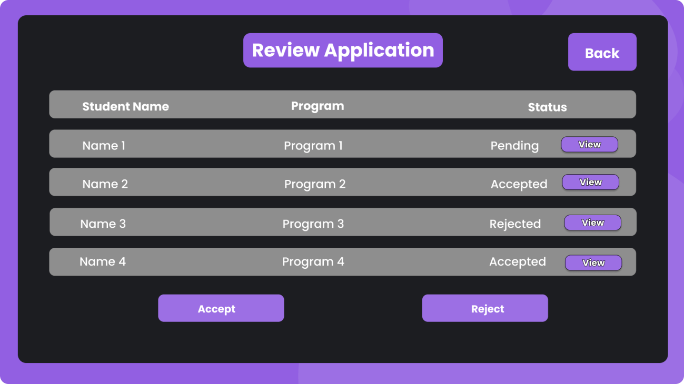
Figure: Review Application Page

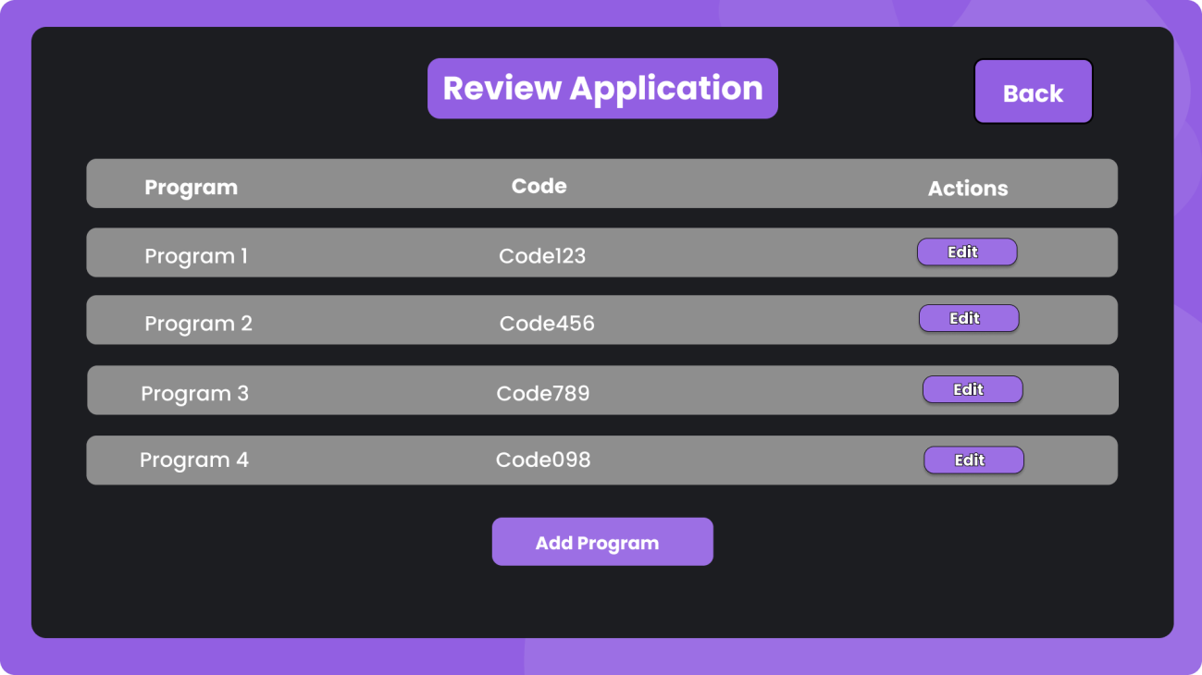
Figure: Review Page

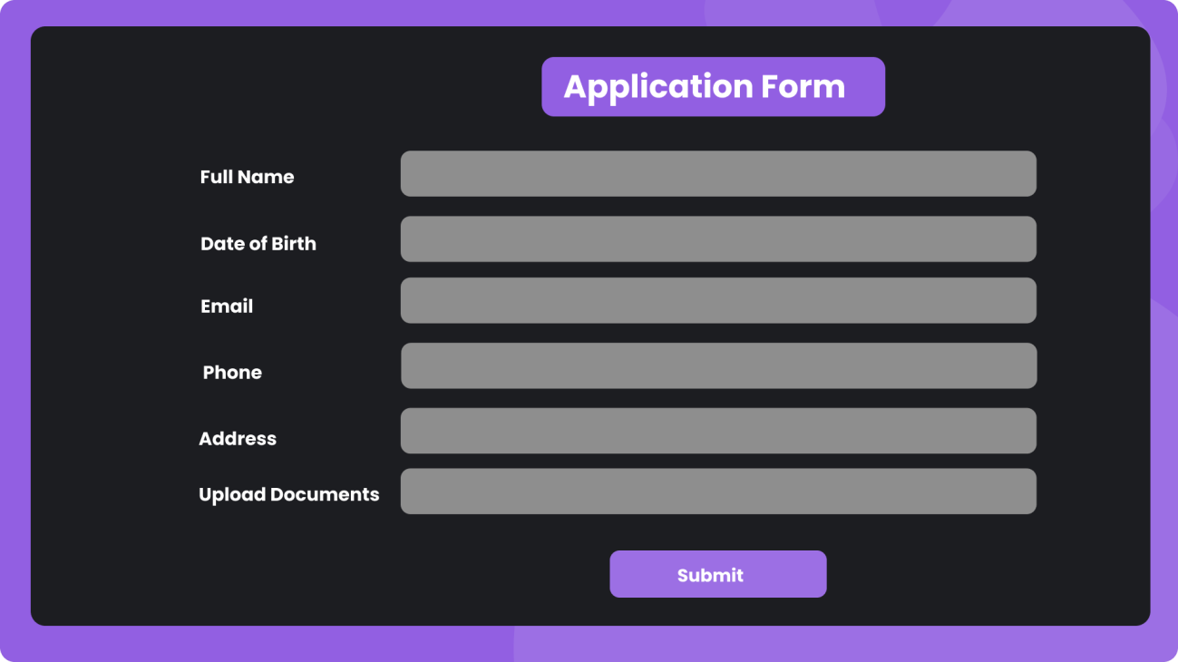
Figure: Application Form Page

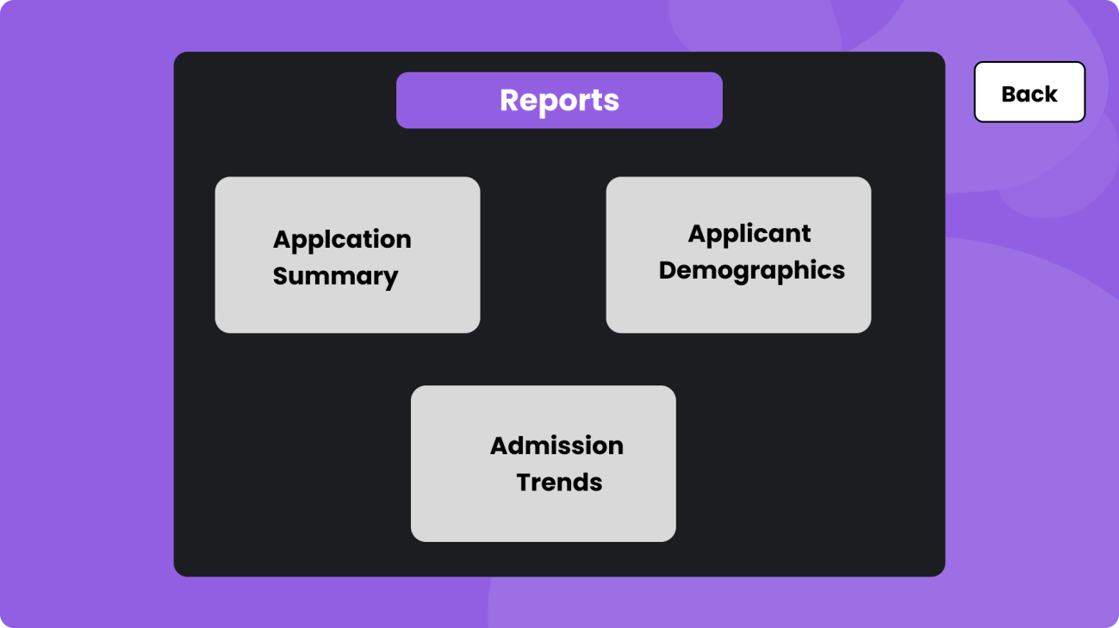
Figure: Reports Page

Scenario Description:
In a university admission management system, a student may apply to multiple academic programs. Each application is submitted by exactly one student. A student is identified by a student ID. The system also stores student name, email, phone number, and address. A student’s address is composed of house number, street name, and city.

A program is identified by a unique program code. The system stores the program name, department name, and program level (e.g., Bachelor's, Master's). Each program belongs to exactly one department, and a department must have at least one program.

During the admission process, a student submits an application form. The form records the date of submission, selected program, and any uploaded documents. A student may submit multiple applications to different programs, but only one application per program.

Each application must go through an admission test. The system stores the test ID, test date, total marks, and passing marks. A student can appear in one or more admission tests, and each test result is linked to a specific application.

A student may be accepted or rejected for a program based on test results. The admission result includes application ID, result status (Accepted/Rejected), and comments from the university staff.

Staff members who manage the admission process are identified by a staff ID. The system stores the staff member’s name, role (e.g., reviewer, manager), and department. Each application is reviewed and processed by at least one staff member.

The system also stores information on documents submitted by the applicant, such as academic transcripts, ID proof, and certificates. Each document is linked to a specific application.
In a university admission management system, a student may apply to multiple academic programs. Each application is submitted by exactly one student. A student is identified by a student ID. The system also stores student name, email, phone number, and address. A student’s address is composed of house number, street name, and city.

A program is identified by a unique program code. The system stores the program name, department name, and program level (e.g., Bachelor's, Master's). Each program belongs to exactly one department, and a department must have at least one program.

During the admission process, a student submits an application form. The form records the date of submission, selected program, and any uploaded documents. A student may submit multiple applications to different programs, but only one application per program.

Each application must go through an admission test. The system stores the test ID, test date, total marks, and passing marks. A student can appear in one or more admission tests, and each test result is linked to a specific application.

A student may be accepted or rejected for a program based on test results. The admission result includes application ID, result status (Accepted/Rejected), and comments from the university staff.

Staff members who manage the admission process are identified by a staff ID. The system stores the staff member’s name, role (e.g., reviewer, manager), and department. Each application is reviewed and processed by at least one staff member.

The system also stores information on documents submitted by the applicant, such as academic transcripts, ID proof, and certificates. Each document is linked to a specific application.

ER Diagram:

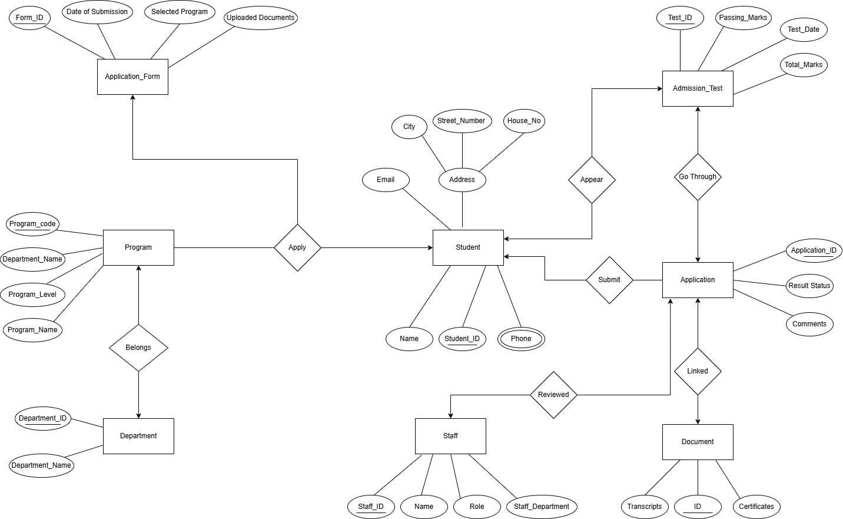

Normalization:
Apply UNF
Apply ( Student_ID, Name, Phone, Email, City, Street_No , House_No, , form_id, date_of_submission, selected_program, uploaded_documents, program_code, department_name, program_level, program_name)

1NF
Phone is a multi valued attribute.
- Student_ID, Name, Phone, Email, City, Street_No , House_No, , form_id, date_of_submission, selected_program, uploaded_documents, program_code, department_name, program_level, program_name

2NF
- Student_ID, Name, Phone, Email, City, Street_No , House_No,
- form_id, date_of_submission, selected_program, uploaded_documents,
- program_code, department_name, program_level, program_name
- SFP_Id, Student_ID, form_id, program_code

3NF
- Student_ID, Name, Phone, Email, City, Street_No , House_No,
- form_id, date_of_submission, selected_program, uploaded_documents,
- program_code, program_level, DepPro_Id (FK)
- SFP_Id, Student_ID, form_id, program_code
- DepPro_Id, department_name, program_name

Table Creation
- Student_ID, Name, Phone, Email, City, Street_No , House_No,
- form_id, date_of_submission, selected_program, uploaded_documents,
- program_code, program_level, DepPro_Id (FK)
- SFP_Id, Student_ID, form_id, program_code
- DepPro_Id, department_name, program_name

Belongs UNF
Belongs (program_code, department_name, program_level, program_name, department_id, department_name)

1NF
There is no multi valued attribute. Relation already in 1NF.
program_code, department_name, program_level, program_name, department_id, department_name

2NF
- program_code, department_name, program_level, program_name
- department_id, department_name
- DP_Id, program_code, department_id

3NF
- program_code, program_level, DepPro_Id (FK)
- department_id, department_name
- DP_Id, program_code, department_id
- DepPro_Id, department_name, program_name

Table Creation
- program_code, program_level, DepPro_Id (FK)
- department_id, department_name
- DP_Id, program_code, department_id
- DepPro_Id, department_name, program_name

Appear UNF
Appear (student_id, name, email, phone, city, street_number, house_no, test_id, passing_marks, test_date, total_marks)

1NF
Phone is a multi valued attribute.
- student_id, name, email, phone, city, street_number, house_no, test_id, passing_marks, test_date, total_marks

2NF
- student_id, name, email, phone, city, street_number, house_no
- test_id, passing_marks, test_date, total_marks
- ST_Id, student_id, test_id

3NF
- student_id, name, email, phone, city, street_number, house_no

- test_id, test_date, PT_Id (FK)
- ST_Id, student_id, test_id
- PT_Id, passing_marks, total_marks

Table Creation
- student_id, name, email, phone, city, street_number, house_no
- test_id, test_date, PT_Id (FK)
- ST_Id, student_id, test_id
- PT_Id, passing_marks, total_marks

Go Through UNF
Go Through (application_id, result_status, comments, test_id, passing_marks, test_date, total_marks)

1NF
There is no multi valued attribute. Relation already in 1NF.
- application_id, result_status, comments, test_id, passing_marks, test_date, total_marks

2NF
- application_id, result_status, comments,
- test_id, passing_marks, test_date, total_marks
- AT_Id, application_id, test_id,

3NF
- application_id, result_status, comments,
- test_id, test_date, total_marks
- AT_Id, application_id, test_id,
- PT_Id, passing_marks, total_marks

Table Creation
- application_id, result_status, comments,
- test_id, test_date, total_marks
- AT_Id, application_id, test_id,
- PT_Id, passing_marks, total_marks

Submit

UNF
Submit ( application_id, result_status, comments, student_id, name, email, phone, address, city, street_number, house_no)

1NF
Phone is a multi valued attribute.
- application_id, result_status, comments, student_id, name, email, phone, address, city, street_number, house_no

2NF
- application_id, result_status, comments
- student_id, name, email, phone, address, city, street_number, house_no
- AS_Id, application_id, student_id,

3NF
There is no transitive dependency. Relation already in 3NF
- application_id, result_status, comments
- student_id, name, email, phone, address, city, street_number, house_no
- AS_Id, application_id, student_id,

Table Creation
- application_id, result_status, comments
- student_id, name, email, phone, address, city, street_number, house_no
- AS_Id, application_id, student_id,

Linked UNF
Linked (application_id, date_of_submission, selected_program, uploaded_documents, document_id, transcripts, certificates)

1NF
There is no multi valued attribute. Relation already in 1NF.
- application_id, date_of_submission, selected_program, uploaded_documents, document_id, transcripts, certificates

2NF
- application_id, date_of_submission, selected_program, uploaded_documents,
- document_id, transcripts, certificates
- AD_Id, application_id, document_id,

3NF
There is no transitive dependency. Relation already in 3NF
- application_id, date_of_submission, selected_program, uploaded_documents,
- document_id, transcripts, certificates
- AD_Id, application_id, document_id,

Table Creation
- application_id, date_of_submission, selected_program, uploaded_documents,
- document_id, transcripts, certificates
- AD_Id, application_id, document_id,

Reviewed UNF
Reviewed (application_id, result_status, comments, staff_id, name, role, staff_department)

1NF
There is no multi valued attribute. Relation already in 1NF.
- application_id, result_status, comments, staff_id, name, role, staff_department

2NF
- application_id, result_status, comments
- staff_id, name, role, staff_department
- AS_Id, application_id, staff_id

3NF
There is no transitive dependency. Relation already in 3NF
- application_id, result_status, comments
- staff_id, name, role, staff_department
- AS_Id, application_id, staff_id

Table Creation
- application_id, result_status, comments
- staff_id, name, role, staff_department
- AS_Id, application_id, staff_id

Temporary Tables
  - Student_ID, Name, Phone, Email, City, Street_No , House_No,
  - form_id, date_of_submission, selected_program, uploaded_documents,
  - program_code, program_level, DepPro_Id (FK)

  - SFP_Id, Student_ID, form_id, program_code
  - DepPro_Id, department_name, program_name
  - program_code, program_level, DepPro_Id (FK)
  - department_id, department_name
  - DP_Id, program_code, department_id
  - DepPro_Id, department_name, program_name
  - student_id, name, email, phone, city, street_no, house_no
  - test_id, test_date, PT_Id (FK)
  - ST_Id, student_id, test_id
  - PT_Id, passing_marks, total_marks
  - application_id, result_status, comments,
  - test_id, test_date, total_marks
  - AT_Id, application_id, test_id,
  - PT_Id, passing_marks, total_marks
  - application_id, result_status, comments
  - student_id, name, email, phone, city, street_number, house_no
  - AS_Id, application_id, student_id,
  - application_id, date_of_submission, selected_program, uploaded_documents,
  - document_id, transcripts, certificates
  - AD_Id, application_id, document_id,
  - application_id, result_status, comments
  - staff_id, name, role, staff_department
  - AS_Id, application_id, staff_id

Final Tables
- Student_ID, Name, Phone, Email, City, Street_No , House_No,
- form_id, date_of_submission, selected_program, uploaded_documents,
- program_code, program_level, DepPro_Id (FK)
- SFP_Id, Student_ID, form_id, program_code
- DepPro_Id, department_name, program_name
- department_id, department_name
- DP_Id, program_code, department_id
- test_id, test_date, PT_Id (FK)

- ST_Id, student_id, test_id
- PT_Id, passing_marks, total_marks
- application_id, result_status, comments,
- test_id, test_date, total_marks
- AT_Id, application_id, test_id,
- PT_Id, passing_marks, total_marks
- application_id, result_status, comments
- AS_Id, application_id, student_id,
- application_id, date_of_submission, selected_program, uploaded_documents,
- document_id, transcripts, certificates
- AD_Id, application_id, document_id,
- staff_id, name, role, staff_department
- AS_Id, application_id, staff_id

Table Creation:
Table Name: Test Table CREATE TABLE Test (
test_id NUMBER PRIMARY KEY,
test_date DATE, PT_Id NUMBER,
FOREIGN KEY (PT_Id) REFERENCES PassingTest(PT_Id)
);
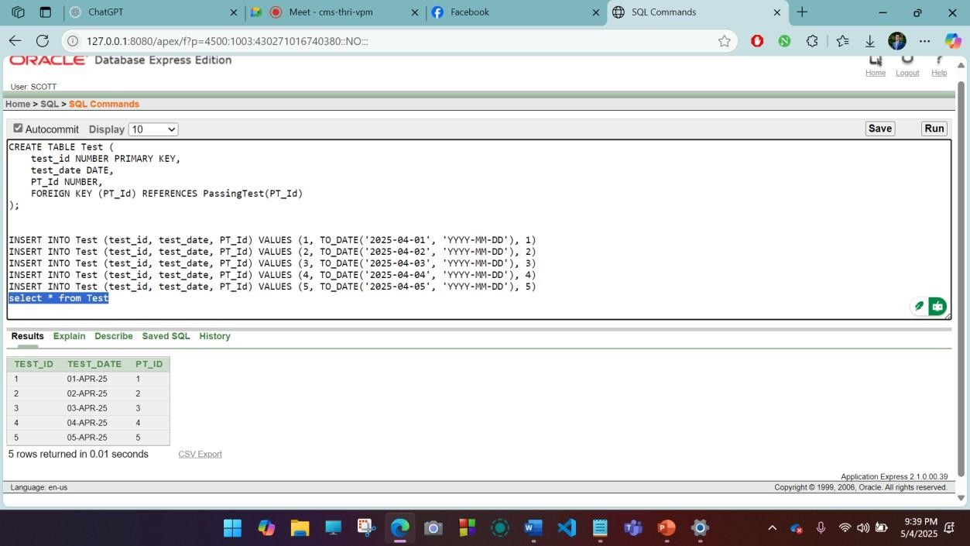

Table Name: Passing Test CREATE

TABLE PassingTest (
PT_Id NUMBER PRIMARY KEY,
passing_marks NUMBER, total_marks NUMBER
);
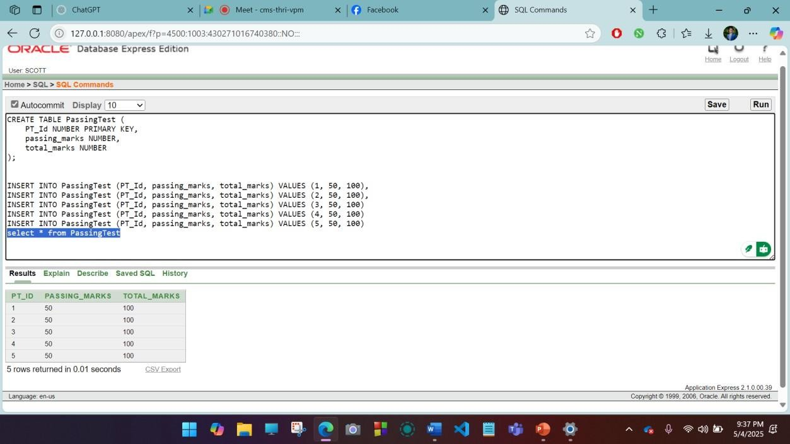

Table Name: DepartmentProgram CREATE TABLE DepartmentProgram (
DepPro_Id NUMBER PRIMARY KEY,
department_name VARCHAR2(100), program_name VARCHAR2(100)
);

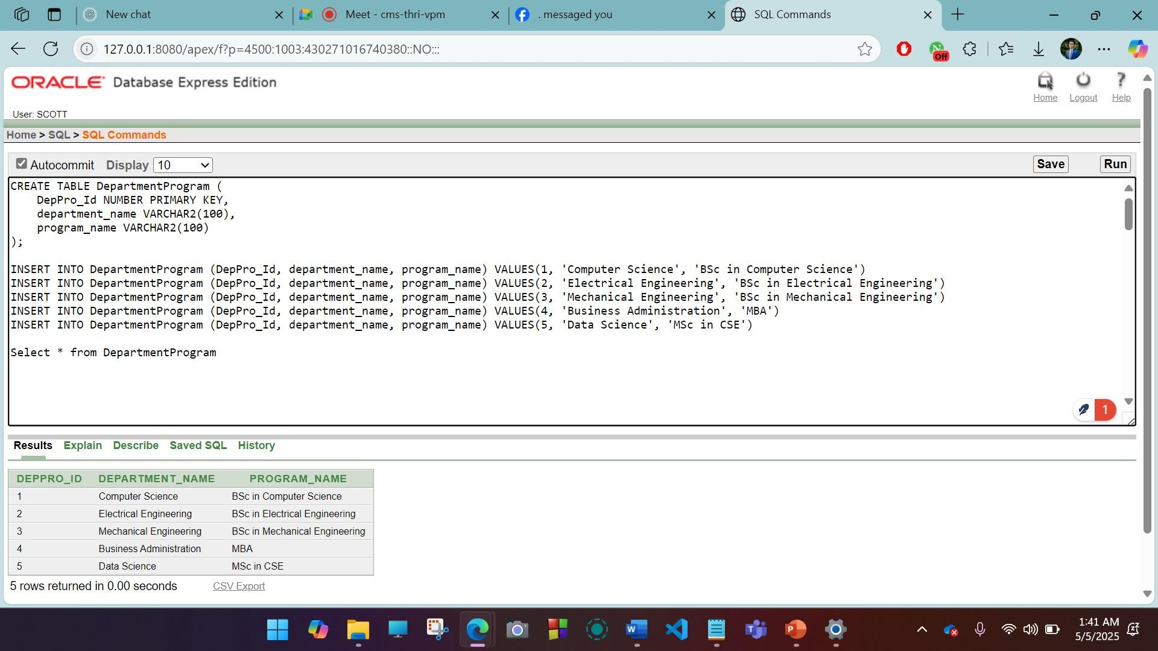
Table Name: StudentTest CREATE TABLE StudentTest (
ST_Id NUMBER PRIMARY KEY,
student_id NUMBER, test_id NUMBER,
FOREIGN KEY (student_id) REFERENCES Student(Student_ID), FOREIGN KEY (test_id) REFERENCES Test(test_id)
);

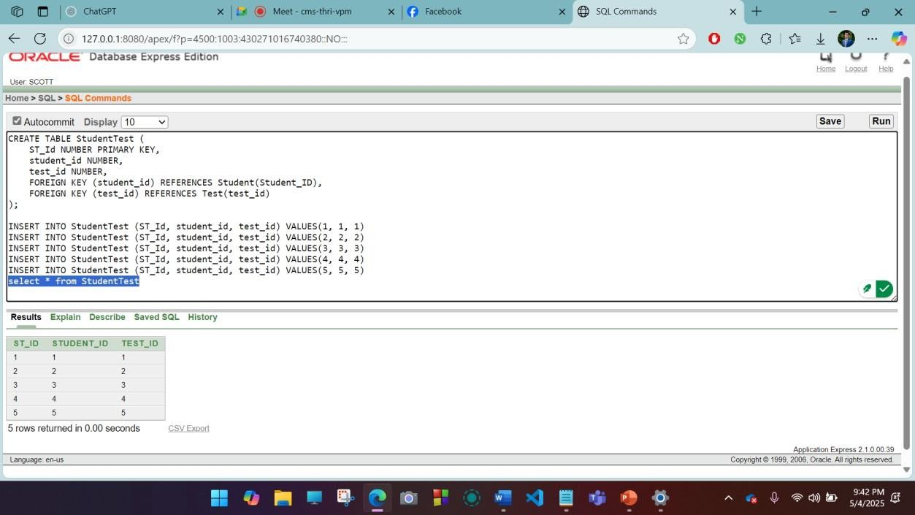
Table Name: Application CREATE TABLE Application (
application_id NUMBER PRIMARY KEY, result_status VARCHAR2(50),
comments VARCHAR2(200)
);
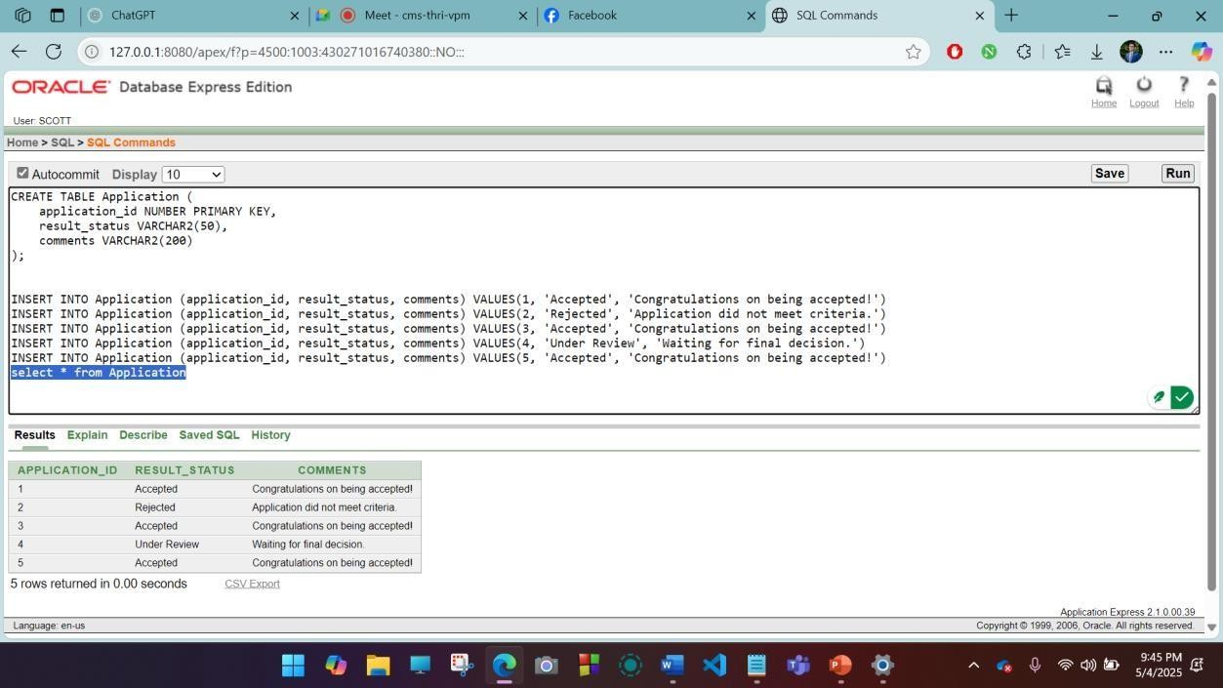

Table Name: Staff CREATE TABLE Staff (
staff_id NUMBER PRIMARY KEY, name VARCHAR2(100),
role VARCHAR2(50),
staff_department VARCHAR2(100)
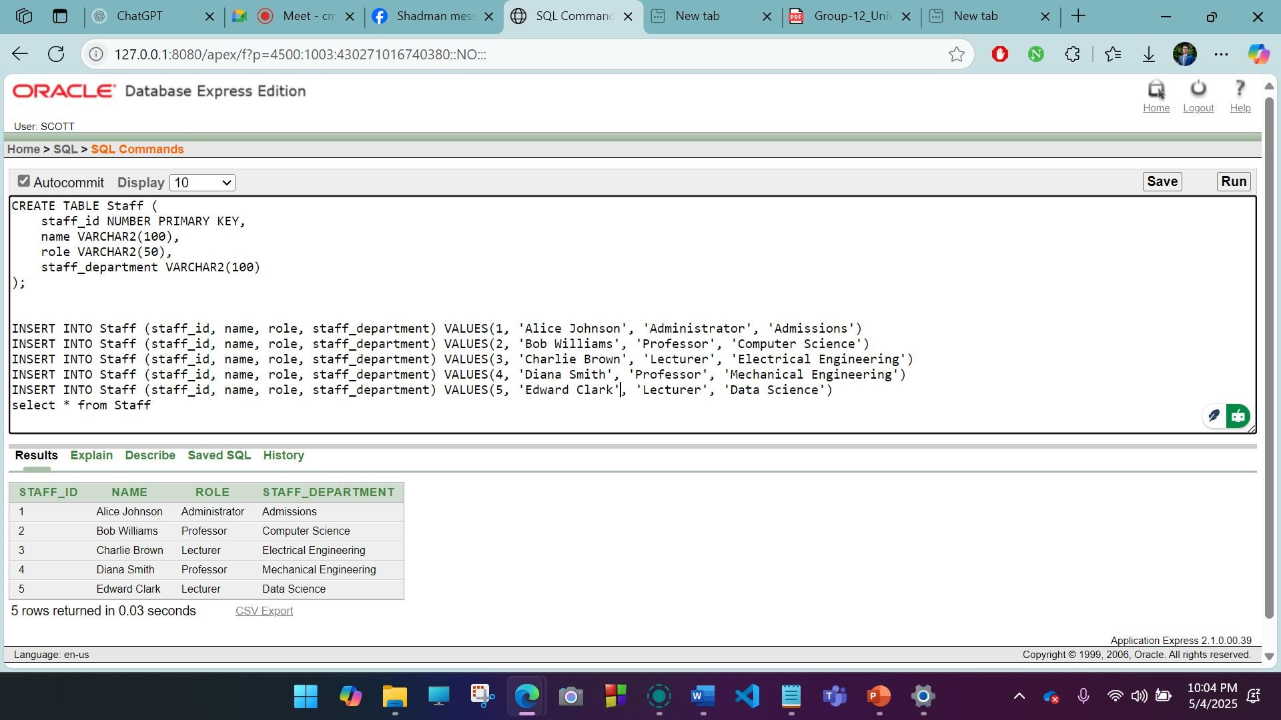
);

Table Name: ApplicationDocument CREATE TABLE ApplicationDocument (
AD_Id NUMBER PRIMARY KEY,
application_id NUMBER, document_id NUMBER,
FOREIGN KEY (application_id) REFERENCES Application(application_id), FOREIGN KEY (document_id) REFERENCES Document(document_id)
);

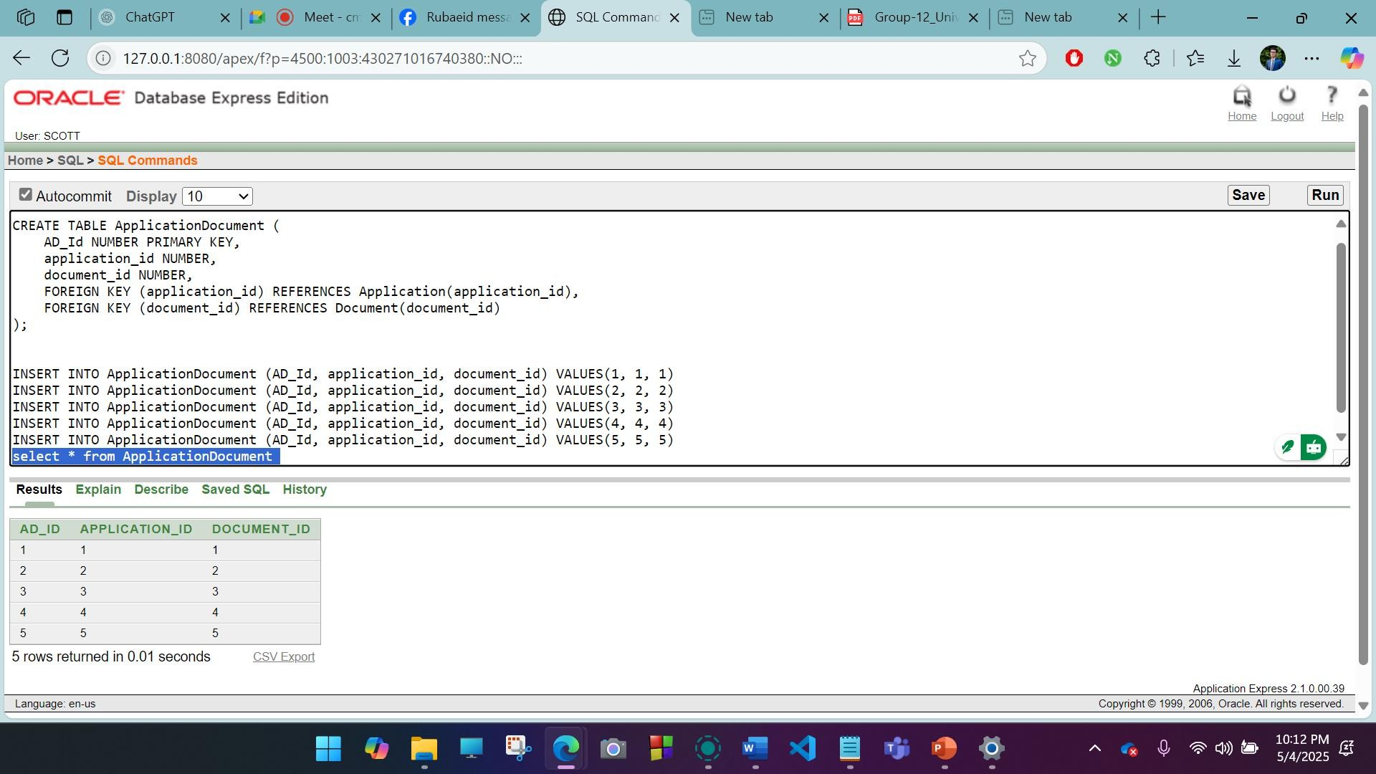

Table Name: Document CREATE TABLE Document (
document_id NUMBER PRIMARY KEY, transcripts VARCHAR2(200),
certificates VARCHAR2(200)
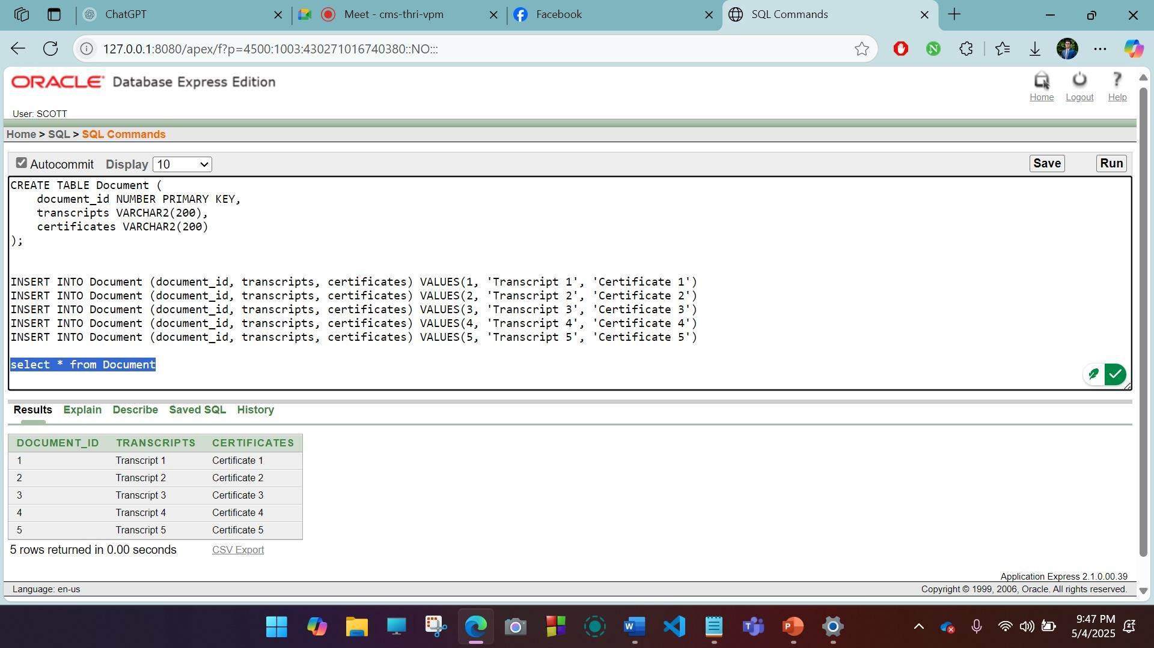
);

Table Name: ApplicationStaff CREATE TABLE ApplicationStaff (
AS_Id NUMBER PRIMARY KEY,
application_id NUMBER, staff_id NUMBER,
FOREIGN KEY (application_id) REFERENCES Application(application_id), FOREIGN KEY (staff_id) REFERENCES Staff(staff_id)
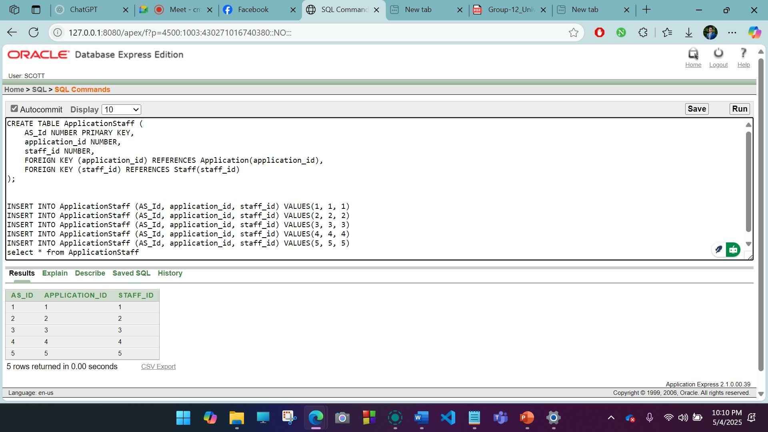
);

Table Name: ApplicationTest CREATE TABLE ApplicationTest (
AT_Id NUMBER PRIMARY KEY,
application_id NUMBER, test_id NUMBER,
FOREIGN KEY (application_id) REFERENCES Application(application_id), FOREIGN KEY (test_id) REFERENCES Test(test_id)
);

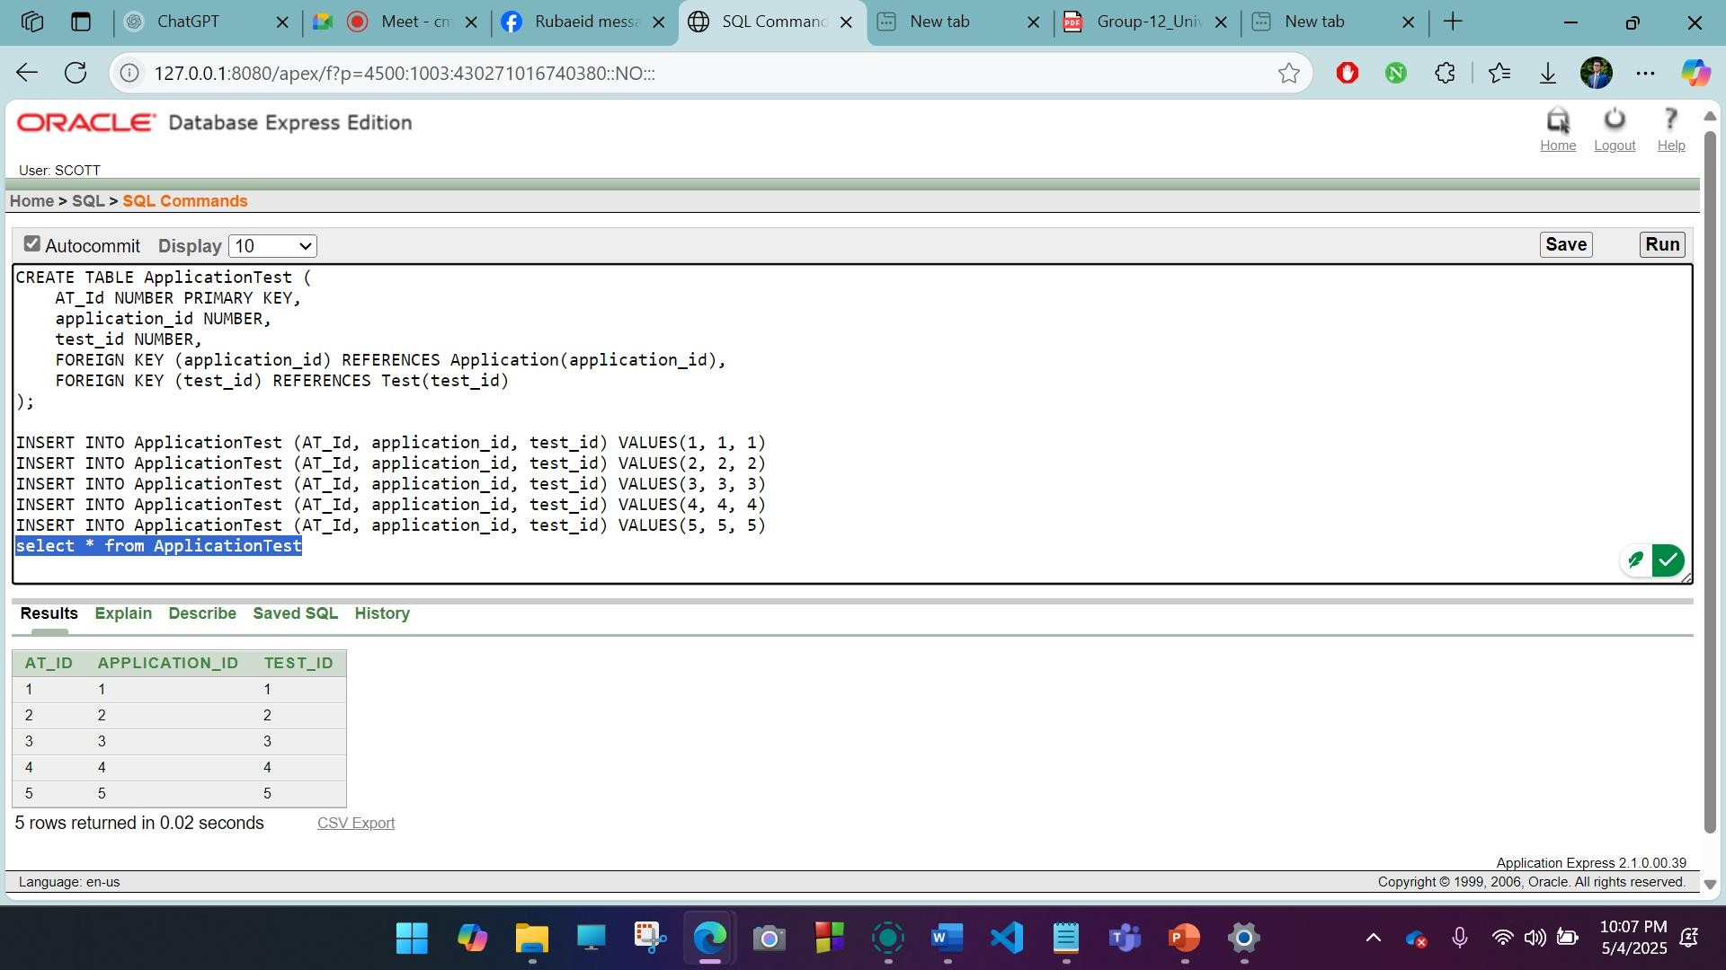

Table Name: StaffAssignment Table
CREATE TABLE StaffAssignment ( StaffAssignment_Id NUMBER PRIMARY KEY, staff_id NUMBER,
department_id NUMBER,
FOREIGN KEY (staff_id) REFERENCES Staff(staff_id),
FOREIGN KEY (department_id) REFERENCES Department(department_id)
);
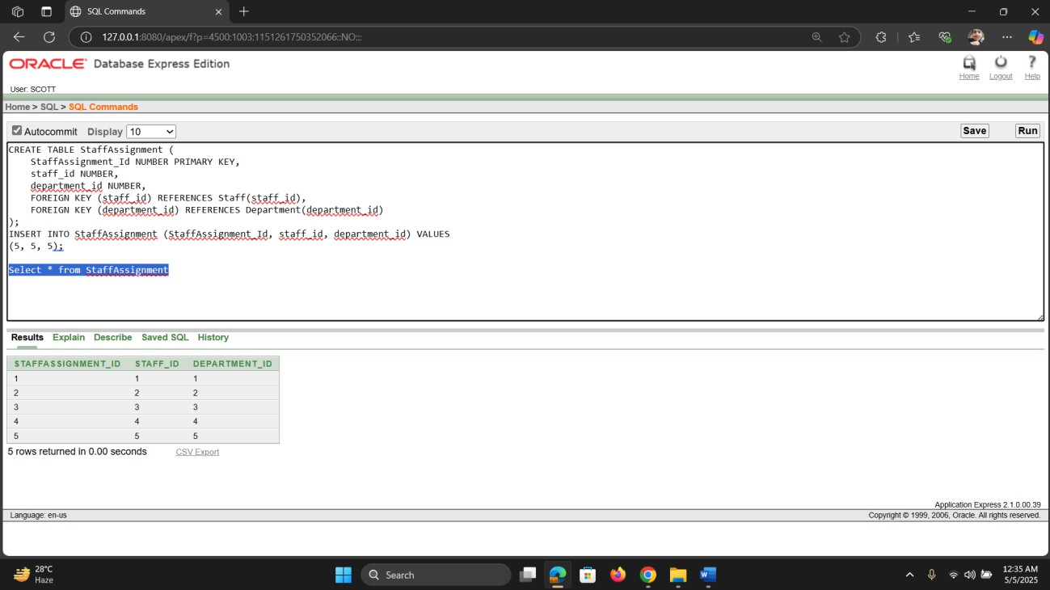

Table Name: Form

CREATE TABLE Form (
form_id NUMBER PRIMARY KEY,
date_of_submission DATE, selected_program VARCHAR2(100), uploaded_documents VARCHAR2(200)
);

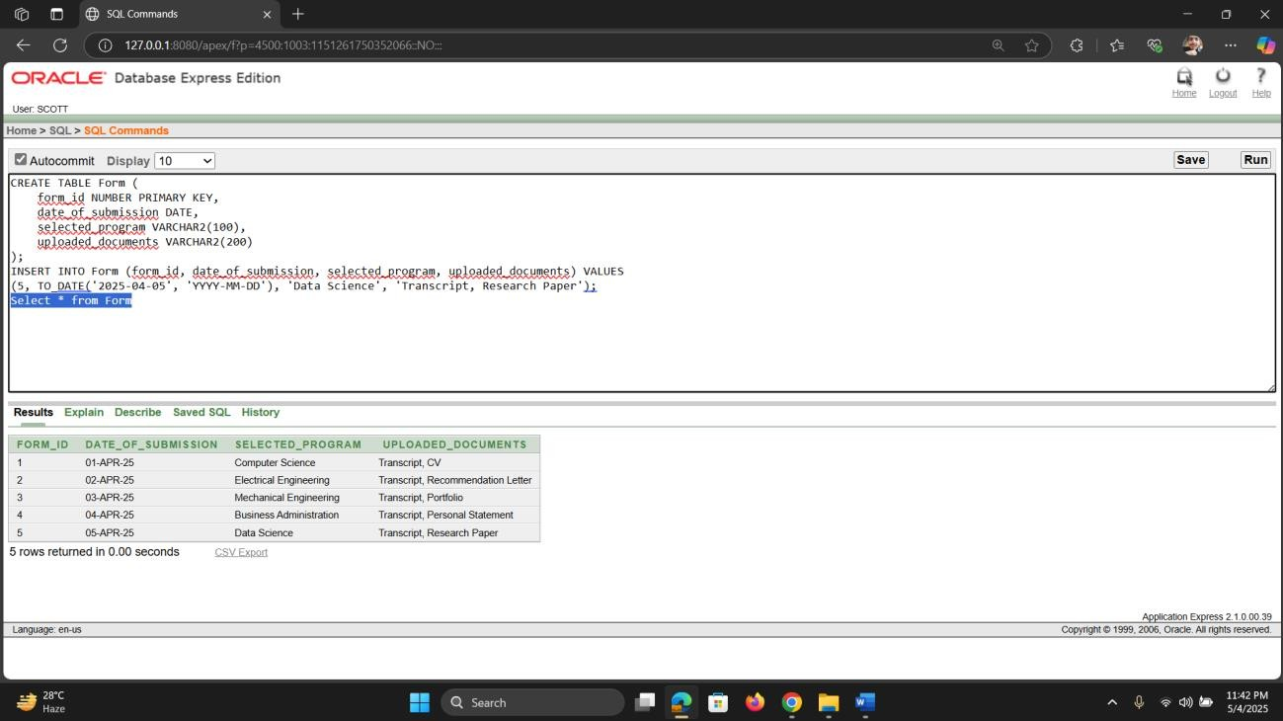
Table Name: Student CREATE TABLE Student (
Student_ID NUMBER PRIMARY KEY, Name VARCHAR2(100),
Phone VARCHAR2(15), Email VARCHAR2(100), City VARCHAR2(50),
Street_No VARCHAR2(20), House_No VARCHAR2(20)
);

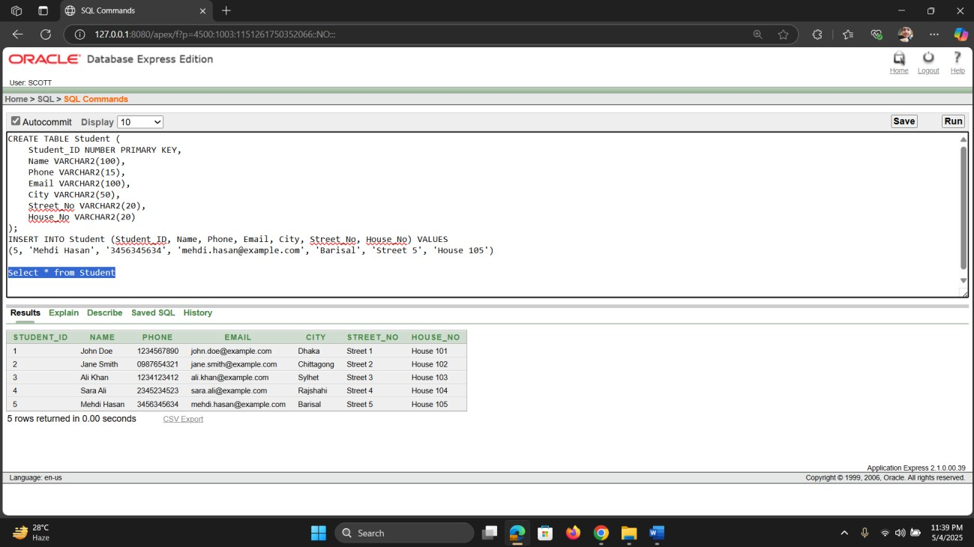

Table Name: Department Table
CREATE TABLE Department ( department_id NUMBER PRIMARY KEY, department_name VARCHAR2(100)
);
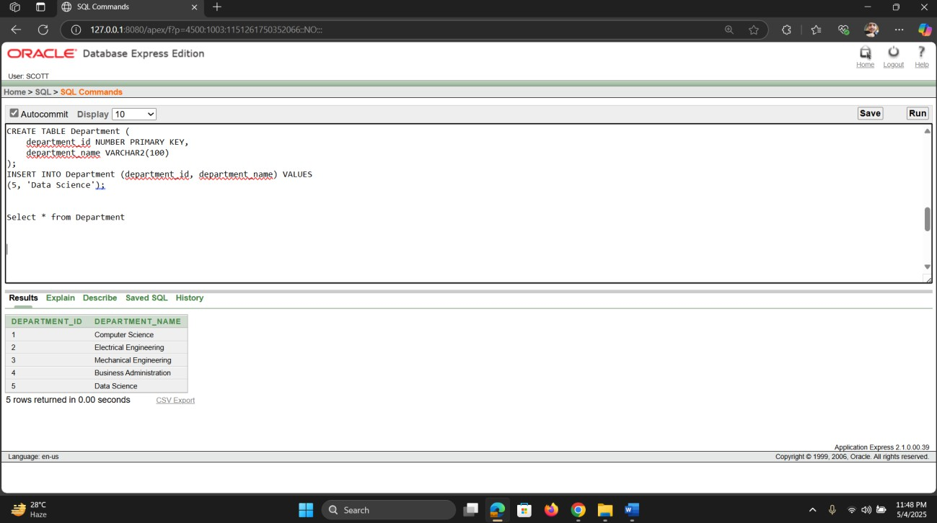

Table Name: DePro_Assignment CREATE TABLE DepPro_Assignment (
DP_Id NUMBER PRIMARY KEY,
program_code VARCHAR2(50), department_id NUMBER,
FOREIGN KEY (program_code) REFERENCES Program(program_code), FOREIGN KEY (department_id) REFERENCES Department(department_id)
);

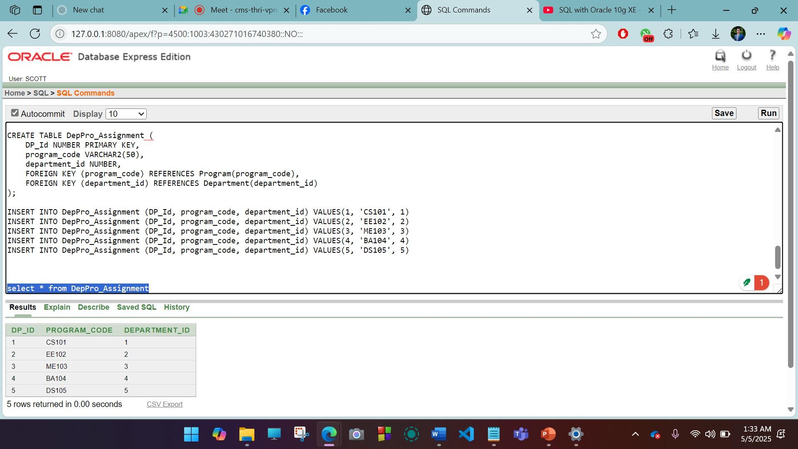

Table Name: SFP CREATE TABLE SFP (
SFP_Id NUMBER PRIMARY KEY,
Student_ID NUMBER, form_id NUMBER,
program_code VARCHAR2(50),
FOREIGN KEY (Student_ID) REFERENCES Student(Student_ID), FOREIGN KEY (form_id) REFERENCES Form(form_id),
FOREIGN KEY (program_code) REFERENCES Program(program_code)
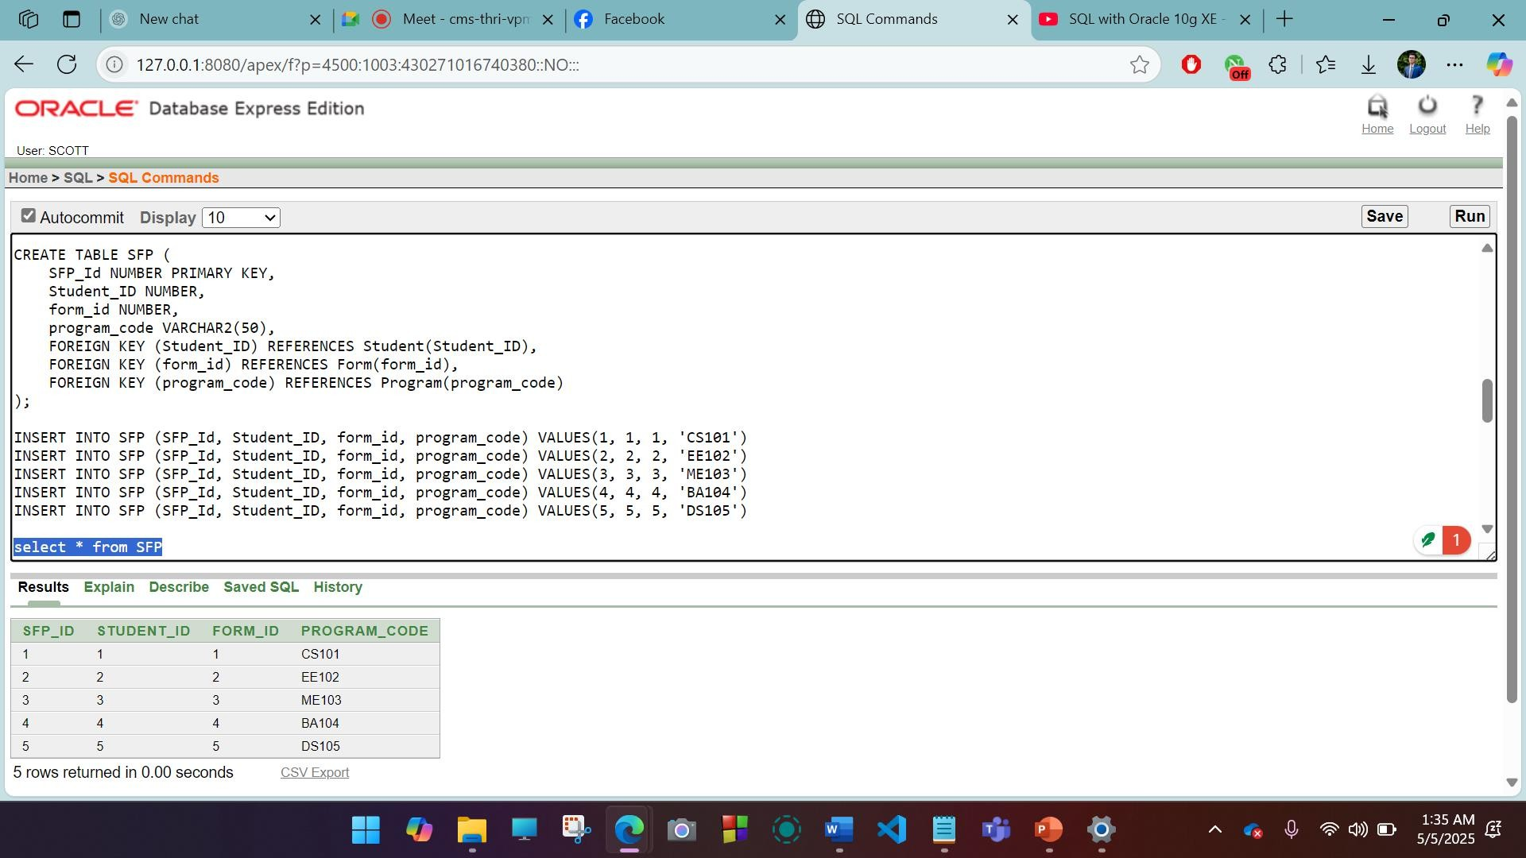
);

Table Name: Program CREATE TABLE Program (
program_code VARCHAR2(50) PRIMARY KEY, program_level VARCHAR2(50),
DepPro_Id NUMBER,
FOREIGN KEY (DepPro_Id) REFERENCES DepartmentProgram(DepPro_Id)
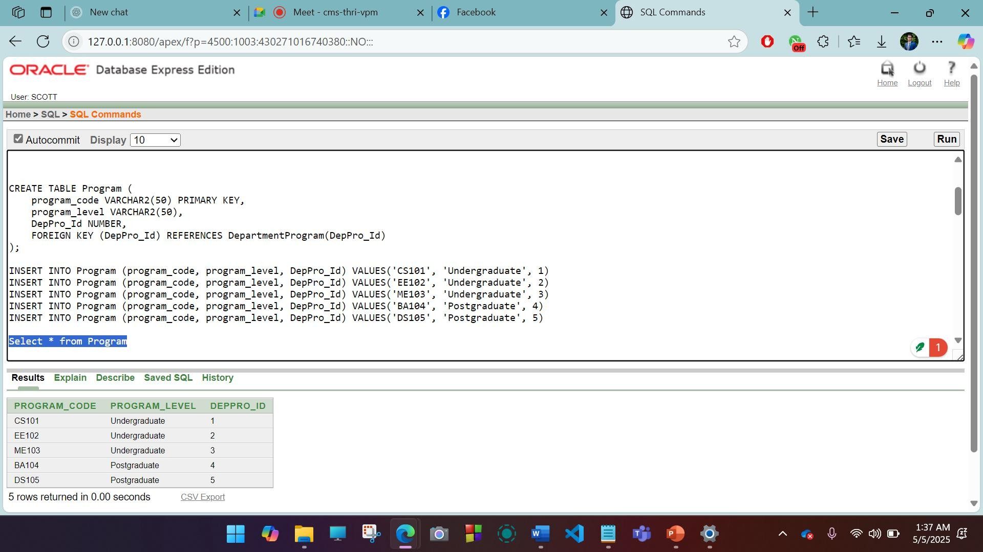
);

Table Name: DepartmentProgram CREATE TABLE DepartmentProgram (
DepPro_Id NUMBER PRIMARY KEY,
department_name VARCHAR2(100), program_name VARCHAR2(100)
);



Table Name: ApplicationDocument CREATE TABLE ApplicationDocument (
AD_Id NUMBER PRIMARY KEY,
application_id NUMBER, document_id NUMBER,
FOREIGN KEY (application_id) REFERENCES Application(application_id), FOREIGN KEY (document_id) REFERENCES Document(document_id)
);

Table Name: StaffAssignment Table
CREATE TABLE StaffAssignment ( StaffAssignment_Id NUMBER PRIMARY KEY, staff_id NUMBER,
department_id NUMBER,
FOREIGN KEY (staff_id) REFERENCES Staff(staff_id),
FOREIGN KEY (department_id) REFERENCES Department(department_id)
);



Table Name: StaffApplication CREATE TABLE Staff (
staff_id NUMBER PRIMARY KEY, name VARCHAR2(100),
role VARCHAR2(50),
staff_department VARCHAR2(100)

);

Data Insertion:

Table Name: Test Table

INSERT INTO Test (test_id, test_date, PT_Id) VALUES (1, TO_DATE('2025-04-01', 'YYYY- MM-DD'), 1)
INSERT INTO Test (test_id, test_date, PT_Id) VALUES (2, TO_DATE('2025-04-02', 'YYYY- MM-DD'), 2)
INSERT INTO Test (test_id, test_date, PT_Id) VALUES (3, TO_DATE('2025-04-03', 'YYYY- MM-DD'), 3)
INSERT INTO Test (test_id, test_date, PT_Id) VALUES (4, TO_DATE('2025-04-04', 'YYYY- MM-DD'), 4)
INSERT INTO Test (test_id, test_date, PT_Id) VALUES (5, TO_DATE('2025-04-05', 'YYYY- MM-DD'), 5)


Table Name: Passing Test

INSERT INTO PassingTest (PT_Id, passing_marks, total_marks) VALUES (1, 50, 100), INSERT INTO PassingTest (PT_Id, passing_marks, total_marks) VALUES (2, 50, 100), INSERT INTO PassingTest (PT_Id, passing_marks, total_marks) VALUES (3, 50, 100) INSERT INTO PassingTest (PT_Id, passing_marks, total_marks) VALUES (4, 50, 100) INSERT INTO PassingTest (PT_Id, passing_marks, total_marks) VALUES (5, 50, 100) select * from PassingTest



Table Name: DepartmentProgram

INSERT INTO DepartmentProgram (DepPro_Id, department_name, program_name) VALUES(1, 'Computer Science', 'BSc in Computer Science')
INSERT INTO DepartmentProgram (DepPro_Id, department_name, program_name) VALUES(2, 'Electrical Engineering', 'BSc in Electrical Engineering')
INSERT INTO DepartmentProgram (DepPro_Id, department_name, program_name) VALUES(3, 'Mechanical Engineering', 'BSc in Mechanical Engineering')
INSERT INTO DepartmentProgram (DepPro_Id, department_name, program_name) VALUES(4, 'Business Administration', 'MBA')
INSERT INTO DepartmentProgram (DepPro_Id, department_name, program_name) VALUES(5, 'Data Science', 'MSc in CSE')


Select * from DepartmentProgram

Table Name: StudentTest

INSERT INTO StudentTest (ST_Id, student_id, test_id) VALUES(1, 1, 1) INSERT INTO StudentTest (ST_Id, student_id, test_id) VALUES(2, 2, 2) INSERT INTO StudentTest (ST_Id, student_id, test_id) VALUES(3, 3, 3) INSERT INTO StudentTest (ST_Id, student_id, test_id) VALUES(4, 4, 4) INSERT INTO StudentTest (ST_Id, student_id, test_id) VALUES(5, 5, 5) select
* from StudentTest



Table Name: Application

INSERT INTO Application (application_id, result_status, comments) VALUES(1, 'Accepted', 'Congratulations on being accepted!')
INSERT INTO Application (application_id, result_status, comments) VALUES(2, 'Rejected', 'Application did not meet criteria.')
INSERT INTO Application (application_id, result_status, comments) VALUES(3, 'Accepted', 'Congratulations on being accepted!')
INSERT INTO Application (application_id, result_status, comments) VALUES(4, 'Under Review', 'Waiting for final decision.')
INSERT INTO Application (application_id, result_status, comments) VALUES(5, 'Accepted', 'Congratulations on being accepted!')
select * from Application


Table Name: Staff

INSERT INTO Staff (staff_id, name, role, staff_department) VALUES(1, 'Alice Johnson', 'Administrator', 'Admissions'),
INSERT INTO Staff (staff_id, name, role, staff_department) VALUES (2, 'Bob Williams', 'Professor', 'Computer Science')
INSERT INTO Staff (staff_id, name, role, staff_department) VALUES (3, 'Charlie Brown', 'Lecturer', 'Electrical Engineering'),
INSERT INTO Staff (staff_id, name, role, staff_department) VALUES (4, 'Diana Smith', 'Professor', 'Mechanical Engineering'),

INSERT INTO Staff (staff_id, name, role, staff_department) VALUES INSERT INTO Staff (staff_id, name, role, staff_department) VALUES (5, 'Edward Clark', 'Lecturer', 'Data Science')

Table Name: ApplicationDocument
INSERT INTO ApplicationDocument (AD_Id, application_id, document_id) VALUES(1, 1, 1),
INSERT INTO ApplicationDocument (AD_Id, application_id, document_id) VALUES (2, 2, 2),
INSERT INTO ApplicationDocument (AD_Id, application_id, document_id) VALUES (3, 3, 3),
INSERT INTO ApplicationDocument (AD_Id, application_id, document_id) VALUES (4, 4, 4),

INSERT INTO ApplicationDocument (AD_Id, application_id, document_id) VALUES (5, 5, 5);

Table Name: Document
INSERT INTO Document (document_id, transcripts, certificates) VALUES(1, 'Transcript 1', 'Certificate 1')
INSERT INTO Document (document_id, transcripts, certificates) VALUES(2, 'Transcript 2', 'Certificate 2')
INSERT INTO Document (document_id, transcripts, certificates) VALUES (3, 'Transcript 3', 'Certificate 3')
INSERT INTO Document (document_id, transcripts, certificates) VALUES (4, 'Transcript 4', 'Certificate 4')
INSERT INTO Document (document_id, transcripts, certificates) VALUES (5, 'Transcript 5', 'Certificate 5')



Table Name: ApplicationStaff

INSERT INTO ApplicationStaff (AS_Id, application_id, staff_id) VALUES(1, 1, 1)
INSERT INTO ApplicationStaff (AS_Id, application_id, staff_id) VALUES (2, 2, 2)
INSERT INTO ApplicationStaff (AS_Id, application_id, staff_id) VALUES (3, 3, 3)
(4, 4, 4)
INSERT INTO ApplicationStaff (AS_Id, application_id, staff_id) VALUES (5, 5, 5)



Table Name: ApplicationTest
INSERT INTO ApplicationTest (AT_Id, application_id, test_id) VALUES(1, 1, 1)
INSERT INTO ApplicationTest (AT_Id, application_id, test_id) VALUES (2, 2, 2)
INSERT INTO ApplicationTest (AT_Id, application_id, test_id) VALUES (3, 3, 3)
INSERT INTO ApplicationTest (AT_Id, application_id, test_id) VALUES (4, 4, 4)
INSERT INTO ApplicationTest (AT_Id, application_id, test_id) VALUES (5, 5, 5)



Table Name: StaffAssignment Table
INSERT INTO StaffAssignment (StaffAssignment_Id, staff_id, department_id) VALUES (1, 1, 1)
INSERT INTO StaffAssignment (StaffAssignment_Id, staff_id, department_id) VALUES (2, 2, 2)
INSERT INTO StaffAssignment (StaffAssignment_Id, staff_id, department_id) VALUES (3, 3, 3)
INSERT INTO StaffAssignment (StaffAssignment_Id, staff_id, department_id) VALUES (4, 4, 4)
INSERT INTO StaffAssignment (StaffAssignment_Id, staff_id, department_id) VALUES (5, 5, 5);


Table Name: Form
INSERT INTO Form (form_id, date_of_submission, selected_program, uploaded_documents) VALUES (1, TO_DATE('2025-04-01', 'YYYY-MM-DD'), 'Computer Science', 'Transcript, CV')
INSERT INTO Form (form_id, date_of_submission, selected_program, uploaded_documents) VALUES
(2, TO_DATE('2025-04-02', 'YYYY-MM-DD'), 'Electrical Engineering', 'Transcript, Recommendation Letter')
INSERT INTO Form (form_id, date_of_submission, selected_program, uploaded_documents) VALUES (3, TO_DATE('2025-04-03', 'YYYY-MM-DD'), 'Mechanical Engineering', 'Transcript, Portfolio')
INSERT INTO Form (form_id, date_of_submission, selected_program, uploaded_documents) VALUES
(4, TO_DATE('2025-04-04', 'YYYY-MM-DD'), 'Business Administration', 'Transcript, Personal Statement')
INSERT INTO Form (form_id, date_of_submission, selected_program, uploaded_documents) VALUES (5, TO_DATE('2025-04-05', 'YYYY-MM-DD'), 'Data Science', 'Transcript, Research Paper')


Table Name: Student

INSERT INTO Student (Student_ID, Name, Phone, Email, City, Street_No, House_No) VALUES (1, 'John Doe', '1234567890', 'john.doe@example.com', 'Dhaka', 'Street 1', 'House 101')
INSERT INTO Student (Student_ID, Name, Phone, Email, City, Street_No, House_No) VALUES (2, 'Jane Smith', '0987654321', 'jane.smith@example.com', 'Chittagong', 'Street 2', 'House 102') INSERT INTO Student (Student_ID, Name, Phone, Email, City, Street_No, House_No) VALUES (3, 'Ali Khan', '1234123412', 'ali.khan@example.com', 'Sylhet', 'Street 3', 'House 103')
INSERT INTO Student (Student_ID, Name, Phone, Email, City, Street_No, House_No) VALUES (4, 'Sara Ali', '2345234523', 'sara.ali@example.com', 'Rajshahi', 'Street 4', 'House 104')
INSERT INTO Student (Student_ID, Name, Phone, Email, City, Street_No, House_No) VALUES (5, 'Mehdi Hasan', '3456345634', 'mehdi.hasan@example.com', 'Barisal', 'Street 5', 'House 105')



Table Name: Department Table
INSERT INTO Department (department_id, department_name) VALUES (1, 'Computer Science')
INSERT INTO Department (department_id, department_name) VALUES (2, 'Electrical Engineering')
INSERT INTO Department (department_id, department_name) VALUES (3, 'Mechanical Engineering')
INSERT INTO Department (department_id, department_name) VALUES (4, 'Business Administration')
INSERT INTO Department (department_id, department_name) VALUES (5, 'Data Science')


Table Name: DePro_Assignment

INSERT INTO DepPro_Assignment (DP_Id, program_code, department_id) VALUES(1, 'CS101', 1) INSERT INTO DepPro_Assignment (DP_Id, program_code, department_id) VALUES(2, 'EE102', 2) INSERT INTO DepPro_Assignment (DP_Id, program_code, department_id) VALUES(3, 'ME103', 3) INSERT INTO DepPro_Assignment (DP_Id, program_code, department_id) VALUES(4, 'BA104', 4) INSERT INTO DepPro_Assignment (DP_Id, program_code, department_id) VALUES(5, 'DS105', 5)

Table Name: SFP

INSERT INTO SFP (SFP_Id, Student_ID, form_id, program_code) VALUES(1, 1, 1, 'CS101') INSERT INTO SFP (SFP_Id, Student_ID, form_id, program_code) VALUES(2, 2, 2, 'EE102') INSERT INTO SFP (SFP_Id, Student_ID, form_id, program_code) VALUES(3, 3, 3, 'ME103') INSERT INTO SFP (SFP_Id, Student_ID, form_id, program_code) VALUES(4, 4, 4, 'BA104') INSERT INTO SFP (SFP_Id, Student_ID, form_id, program_code) VALUES(5, 5, 5, 'DS105')

select * from SFP



Table Name: Program

INSERT INTO Program (program_code, program_level, DepPro_Id) VALUES('CS101', 'Undergraduate', 1) INSERT INTO Program (program_code, program_level, DepPro_Id) VALUES('EE102', 'Undergraduate', 2) INSERT INTO Program (program_code, program_level, DepPro_Id) VALUES('ME103', 'Undergraduate', 3) INSERT INTO Program (program_code, program_level, DepPro_Id) VALUES('BA104', 'Postgraduate', 4) INSERT INTO Program (program_code, program_level, DepPro_Id) VALUES('DS105', 'Postgraduate', 5)


Select * from Program

Table Name: DepartmentProgram

INSERT INTO DepartmentProgram (DepPro_Id, department_name, program_name) VALUES(1, 'Computer Science', 'BSc in Computer Science')
INSERT INTO DepartmentProgram (DepPro_Id, department_name, program_name) VALUES(2, 'Electrical Engineering', 'BSc in Electrical Engineering')
INSERT INTO DepartmentProgram (DepPro_Id, department_name, program_name) VALUES(3, 'Mechanical Engineering', 'BSc in Mechanical Engineering')
INSERT INTO DepartmentProgram (DepPro_Id, department_name, program_name) VALUES(4, 'Business Administration', 'MBA')
INSERT INTO DepartmentProgram (DepPro_Id, department_name, program_name) VALUES(5, 'Data Science', 'MSc in CSE')


Select * from DepartmentProgram

Table Name: ApplicationDocument

INSERT INTO ApplicationDocument (AD_Id, application_id, document_id) VALUES(1, 1, 1),
INSERT INTO ApplicationDocument (AD_Id, application_id, document_id) VALUES (2, 2, 2),
INSERT INTO ApplicationDocument (AD_Id, application_id, document_id) VALUES (3, 3, 3),
INSERT INTO ApplicationDocument (AD_Id, application_id, document_id) VALUES

(4, 4, 4),
INSERT INTO ApplicationDocument (AD_Id, application_id, document_id) VALUES (5, 5, 5);
Table Name: StaffAssignment Table
INSERT INTO StaffAssignment (StaffAssignment_Id, staff_id, department_id) VALUES (1, 1, 1)
INSERT INTO StaffAssignment (StaffAssignment_Id, staff_id, department_id) VALUES (2, 2, 2)
INSERT INTO StaffAssignment (StaffAssignment_Id, staff_id, department_id) VALUES (3, 3, 3)
INSERT INTO StaffAssignment (StaffAssignment_Id, staff_id, department_id) VALUES (4, 4, 4)
INSERT INTO StaffAssignment (StaffAssignment_Id, staff_id, department_id) VALUES (5, 5, 5);


Table Name: StaffApplication

INSERT INTO Staff (staff_id, name, role, staff_department) VALUES(1, 'Alice Johnson', 'Administrator', 'Admissions'),
INSERT INTO Staff (staff_id, name, role, staff_department) VALUES (2, 'Bob Williams', 'Professor', 'Computer Science')
INSERT INTO Staff (staff_id, name, role, staff_department) VALUES (3, 'Charlie Brown', 'Lecturer', 'Electrical Engineering'),
INSERT INTO Staff (staff_id, name, role, staff_department) VALUES (4, 'Diana Smith', 'Professor', 'Mechanical Engineering'),
INSERT INTO Staff (staff_id, name, role, staff_department) VALUES INSERT INTO Staff (staff_id, name, role, staff_department) VALUES (5, 'Edward Clark', 'Lecturer', 'Data Science')



Basic PL/SQL:
- Variables
Question 1:
"Retrieve the name and phone number of the student with Student_ID = 1 and store them in variables."
-- Project: University Admission Management System
-- Semester: Spring 2024-2025
-- Course: Advanced Database Management Systems
-- Section: A

DECLARE
v_student_name VARCHAR2(100); v_student_phone VARCHAR2(15);

BEGIN
SELECT name, phone
INTO v_student_name, v_student_phone FROM Student
WHERE student_id = 1;

DBMS_OUTPUT.PUT_LINE('Student Name: ' || v_student_name || ', Phone: ' || v_student_phone); END;
/

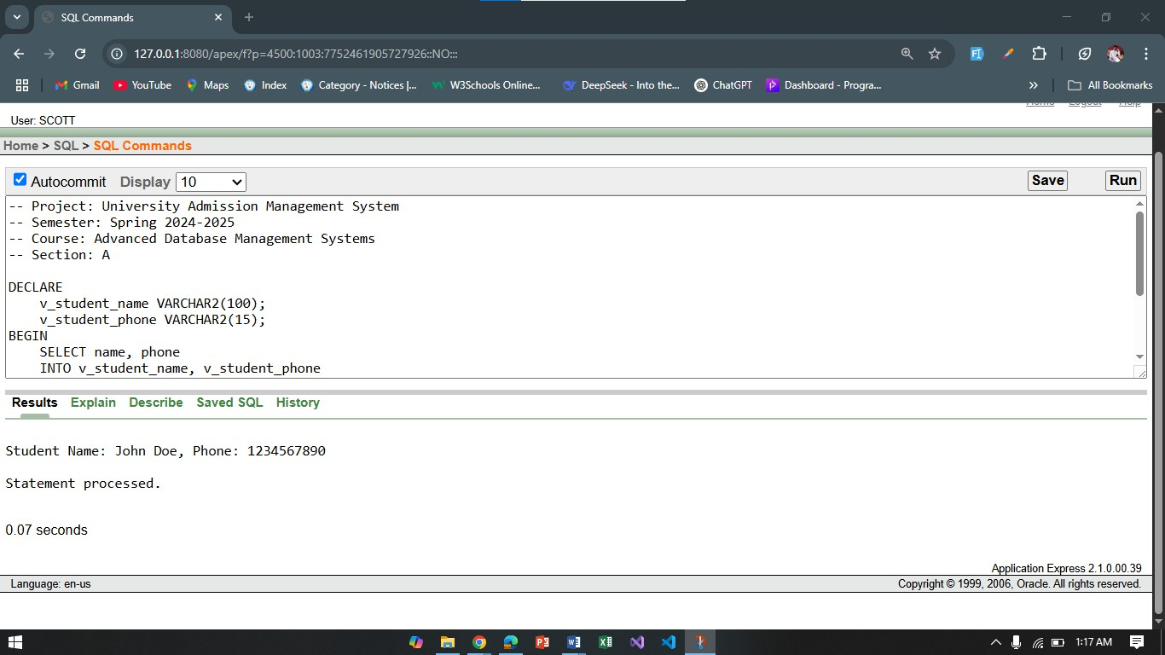
Question 2:
"Retrieve and display the Student_ID and Email for students who have result_status = 'Accepted'."
-- Project: University Admission Management System
-- Semester: Spring 2024-2025
-- Course: Advanced Database Management Systems
-- Section: A

DECLARE
v_student_id NUMBER; v_student_email VARCHAR2(100);

BEGIN
SELECT student_id, email
INTO v_student_id, v_student_email FROM Student
WHERE student_id = (SELECT student_id FROM Application WHERE result_status = 'Accepted' AND ROWNUM = 1);

DBMS_OUTPUT.PUT_LINE('Student ID: ' || v_student_id || ', Email: ' || v_student_email); END;
/

Operators
Question 1:
"Compare if the student's total_marks are greater than the passing marks, and output if they passed or failed."
-- Project: University Admission Management System
-- Semester: Spring 2024-2025

-- Course: Advanced Database Management Systems
-- Section: A

DECLARE
v_total_marks NUMBER := 75; v_passing_marks NUMBER := 50; v_result VARCHAR2(10);

BEGIN
IF v_total_marks >= v_passing_marks THEN v_result := 'Passed';

ELSE
v_result := 'Failed';

END IF;

DBMS_OUTPUT.PUT_LINE('Result: ' || v_result); END;
/
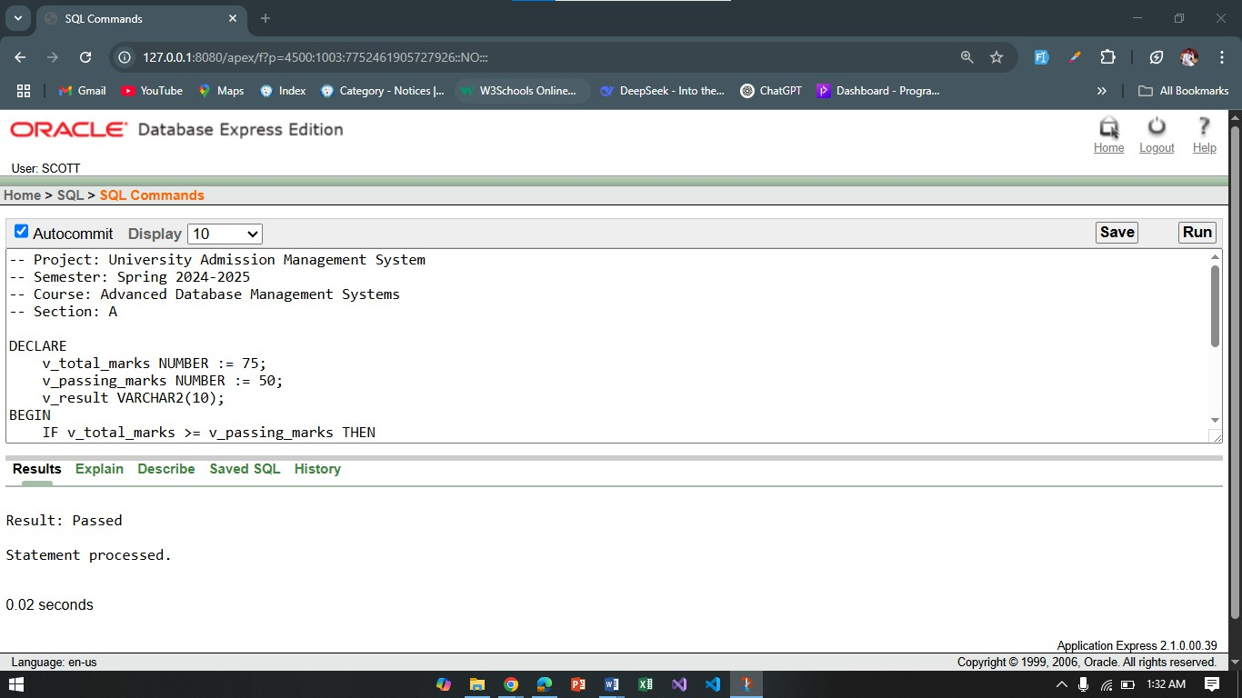
Question 2:
"Check if a student is in the top 5 based on their score."
-- Project: University Admission Management System
-- Semester: Spring 2024-2025
-- Course: Advanced Database Management Systems
-- Section: A

DECLARE
v_student_id NUMBER := 1; v_score NUMBER := 90;

v_is_top_5 VARCHAR2(10); BEGIN
IF v_score > 85 THEN v_is_top_5 := 'Yes';

ELSE
v_is_top_5 := 'No'; END IF;

DBMS_OUTPUT.PUT_LINE('Is Top 5: ' || v_is_top_5); END;
/
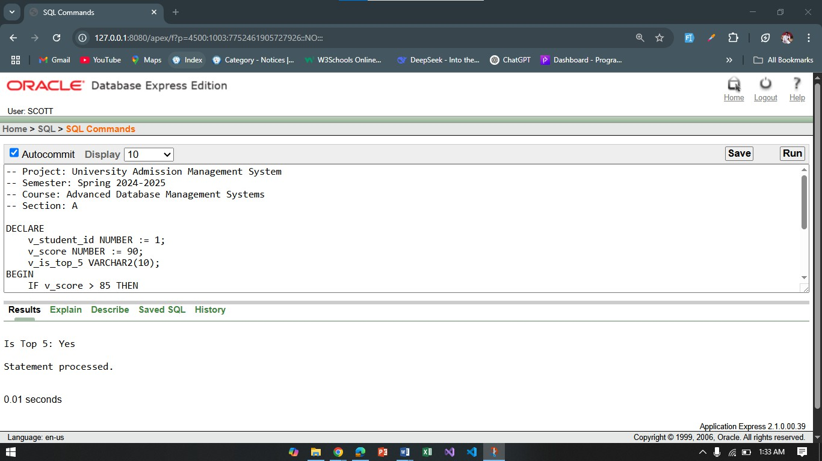

Single-Row Functions
Question 1:
"Retrieve the student's name in uppercase."
-- Project: University Admission Management System
-- Semester: Spring 2024-2025
-- Course: Advanced Database Management Systems
-- Section: A

DECLARE
v_student_name VARCHAR2(100); BEGIN
SELECT UPPER(name)
INTO v_student_name FROM Student WHERE student_id = 1;

DBMS_OUTPUT.PUT_LINE('Uppercase Name: ' || v_student_name); END;
/
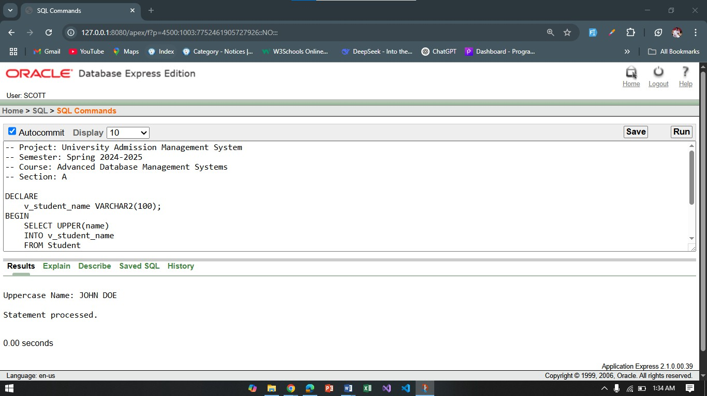
Question 2:
"Get the email of a student and remove leading/trailing spaces."
-- Project: University Admission Management System
-- Semester: Spring 2024-2025
-- Course: Advanced Database Management Systems
-- Section: A

DECLARE
v_student_email VARCHAR2(100); BEGIN
SELECT TRIM(email)
INTO v_student_email FROM Student WHERE student_id = 1;

DBMS_OUTPUT.PUT_LINE('Trimmed Email: ' || v_student_email); END;
/

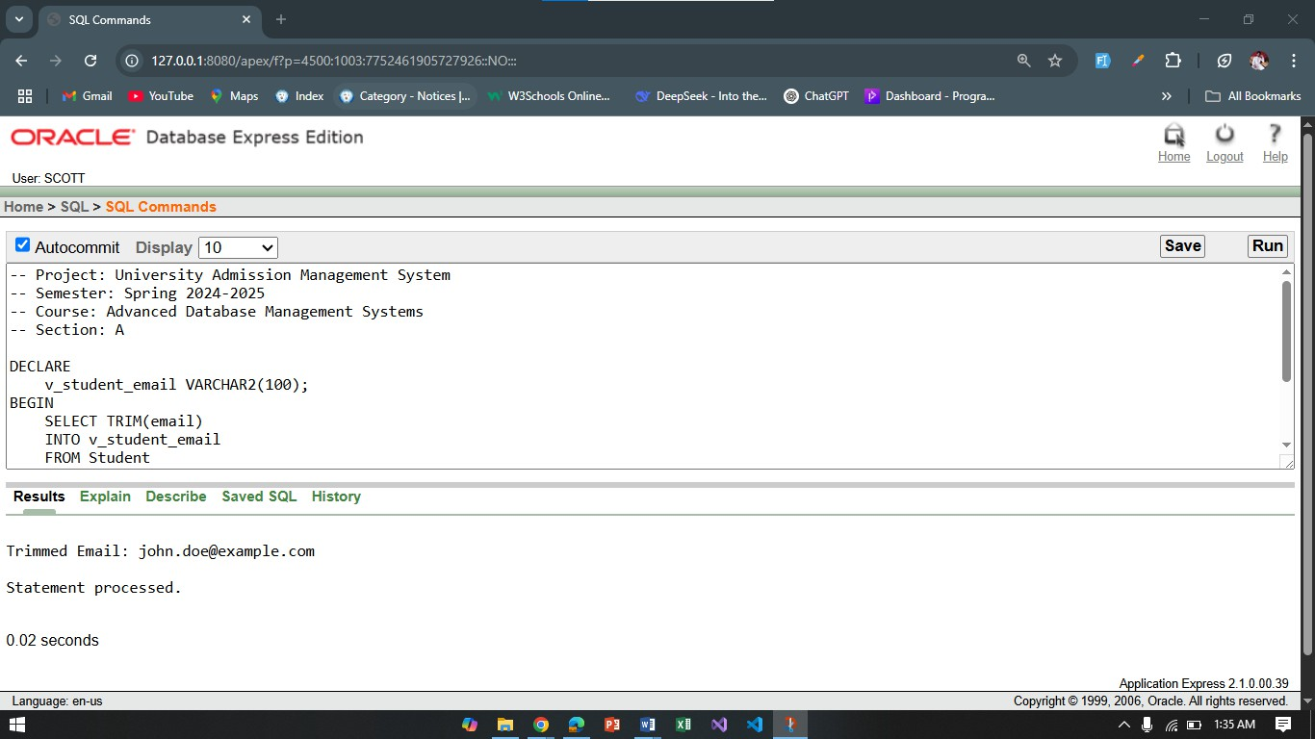

Group Functions
Question 1:
"Find the average total_marks of all students."
-- Project: University Admission Management System
-- Semester: Spring 2024-2025
-- Course: Advanced Database Management Systems
-- Section: A

DECLARE
v_avg_marks NUMBER; BEGIN
SELECT AVG(total_marks) INTO v_avg_marks FROM Test;

DBMS_OUTPUT.PUT_LINE('Average Marks: ' || v_avg_marks); END;
/
Question 2:
"Find the total number of students who have `result_status = 'Accepted'."
-- Project: University Admission Management System
-- Semester: Spring 2024-2025
-- Course: Advanced Database Management Systems
-- Section: A

DECLARE
v_total_accepted NUMBER; BEGIN

SELECT COUNT(*) INTO v_total_accepted FROM Application
WHERE result_status = 'Accepted';

DBMS_OUTPUT.PUT_LINE('Total Accepted Students: ' || v_total_accepted); END;
/
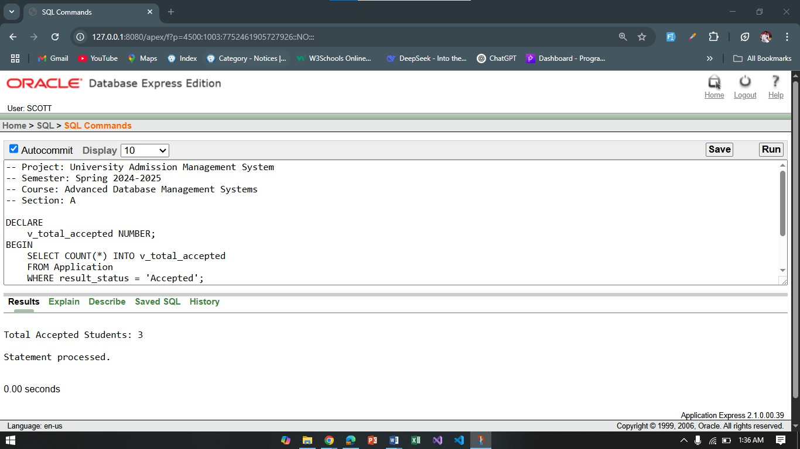

Loop
Question 1:
"Iterate over the first 5 students and print their names."
-- Project: University Admission Management System
-- Semester: Spring 2024-2025
-- Course: Advanced Database Management Systems
-- Section: A

BEGIN
FOR i IN 1..5 LOOP
DBMS_OUTPUT.PUT_LINE('Student ' || i || ' Name: ' || (SELECT name FROM Student WHERE ROWNUM = i));

END LOOP; END;
/
Question 2:
"Print 'Passed' for students whose score is above 70."
-- Project: University Admission Management System
-- Semester: Spring 2024-2025
-- Course: Advanced Database Management Systems

-- Section: A

BEGIN
FOR r IN (SELECT student_id, total_marks FROM Student) LOOP IF r.total_marks > 70 THEN
DBMS_OUTPUT.PUT_LINE('Student ' || r.student_id || ' Passed'); END IF;

END LOOP; END;
/

Conditional Statements
Question 1:
"Check if the student's result status is 'Accepted'."
-- Project: University Admission Management System
-- Semester: Spring 2024-2025
-- Course: Advanced Database Management Systems
-- Section: A

DECLARE
v_result_status VARCHAR2(50); BEGIN
SELECT result_status INTO v_result_status FROM Application
WHERE student_id = 1;

IF v_result_status = 'Accepted' THEN DBMS_OUTPUT.PUT_LINE('Student is Accepted.');

ELSE
DBMS_OUTPUT.PUT_LINE('Student is Not Accepted.'); END IF;

END;
/

Question 2:
"Determine if a student has scored more than 60 marks."
-- Project: University Admission Management System
-- Semester: Spring 2024-2025
-- Course: Advanced Database Management Systems
-- Section: A

DECLARE

v_score NUMBER := 65; BEGIN
IF v_score > 60 THEN
DBMS_OUTPUT.PUT_LINE('Student has scored more than 60 marks.'); ELSE
DBMS_OUTPUT.PUT_LINE('Student has scored less than 60 marks.'); END IF;

END;
/
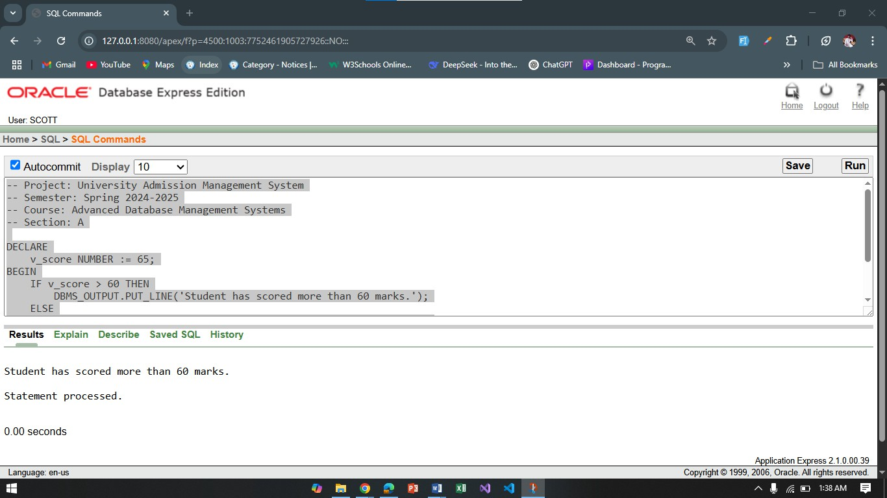

Subquery
Question 1:
"Retrieve the student ID of the student with the highest marks."
-- Project: University Admission Management System
-- Semester: Spring 2024-2025
-- Course: Advanced Database Management Systems
-- Section: A

DECLARE
v_top_student_id NUMBER; BEGIN
SELECT student_id INTO v_top_student_id FROM Student
WHERE student_id = (SELECT student_id FROM Test WHERE total_marks = (SELECT MAX(total_marks) FROM Test));

DBMS_OUTPUT.PUT_LINE('Top Student ID: ' || v_top_student_id);

END;
/
Question 2:
"Find the student_id for students who have a result_status of 'Accepted'."
-- Project: University Admission Management System
-- Semester: Spring 2024-2025
-- Course: Advanced Database Management Systems
-- Section: A

DECLARE
v_student_id NUMBER; BEGIN
SELECT student_id INTO v_student_id FROM Application
WHERE result_status = 'Accepted' AND ROWNUM = 1;

DBMS_OUTPUT.PUT_LINE('Student ID of Accepted Applicant: ' || v_student_id); END;
/

Joining
Question 1:
"Join Student and Application to display student name and application status."
-- Project: University Admission Management System
-- Semester: Spring 2024-2025
-- Course: Advanced Database Management Systems
-- Section: A

BEGIN
FOR r IN (SELECT s.name, a.result_status FROM Student s
JOIN Application a ON s.student_id = a.student_id) LOOP DBMS_OUTPUT.PUT_LINE('Student: ' || r.name || ' - Status: ' || r.result_status);

END LOOP; END;
/
Question 2:
"Join Test and PassingTest to display test date and passing marks."
-- Project: University Admission Management System

-- Semester: Spring 2024-2025
-- Course: Advanced Database Management Systems
-- Section: A

BEGIN
FOR r IN (SELECT t.test_date, pt.passing_marks FROM Test t
JOIN PassingTest pt ON t.PT_Id = pt.PT_Id) LOOP
DBMS_OUTPUT.PUT_LINE('Test Date: ' || r.test_date || ' - Passing Marks: ' || r.passing_marks); END LOOP;

END;
/
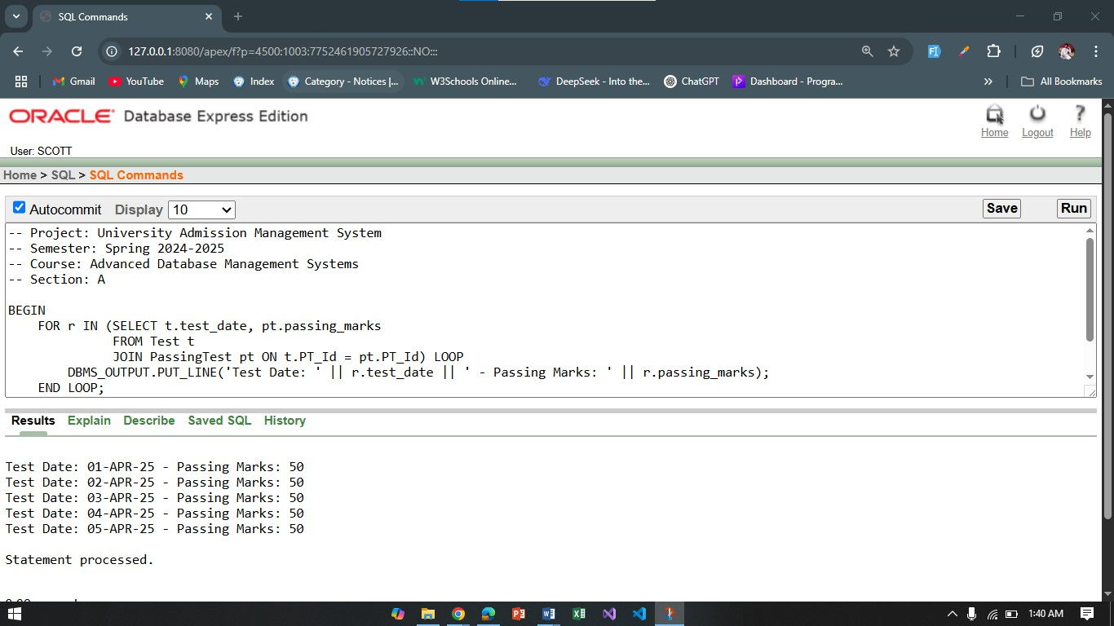
Advanced PL/SQL

- Stored Functions
Question 1:
"Create a function to retrieve the result status of a student based on their student_id."
-- Project: University Admission Management System
-- Semester: Spring 2024-2025
-- Course: Advanced Database Management Systems
-- Section: A

CREATE OR REPLACE FUNCTION get_result_status (p_student_id IN NUMBER)

RETURN VARCHAR2 IS
v_result_status VARCHAR2(50); BEGIN
SELECT result_status

INTO v_result_status FROM Application
WHERE student_id = p_student_id;

RETURN v_result_status; END get_result_status;
/

Question 2:
"Create a function to calculate the total marks of a student in all tests."
-- Project: University Admission Management System
-- Semester: Spring 2024-2025
-- Course: Advanced Database Management Systems
-- Section: A

CREATE OR REPLACE FUNCTION get_total_marks (p_student_id IN NUMBER) RETURN NUMBER IS
v_total_marks NUMBER := 0; BEGIN
SELECT SUM(total_marks) INTO v_total_marks
FROM Test
WHERE student_id = p_student_id;

RETURN v_total_marks; END get_total_marks;
/

Stored Procedures
Question 1:
"Create a stored procedure to update the result status of a student based on their student_id."
-- Project: University Admission Management System
-- Semester: Spring 2024-2025
-- Course: Advanced Database Management Systems
-- Section: A

CREATE OR REPLACE PROCEDURE update_result_status (p_student_id IN NUMBER, p_status IN VARCHAR2)

IS BEGIN
UPDATE Application
SET result_status = p_status WHERE student_id = p_student_id;

COMMIT;
END update_result_status;
/

Question 2:
"Create a stored procedure to add a new student into the Student table."
-- Project: University Admission Management System
-- Semester: Spring 2024-2025
-- Course: Advanced Database Management Systems
-- Section: A

CREATE OR REPLACE PROCEDURE add_student (p_name IN VARCHAR2, p_phone IN VARCHAR2, p_email IN VARCHAR2, p_city IN VARCHAR2)

IS BEGIN
INSERT INTO Student (name, phone, email, city) VALUES (p_name, p_phone, p_email, p_city);

COMMIT;
END add_student;
/
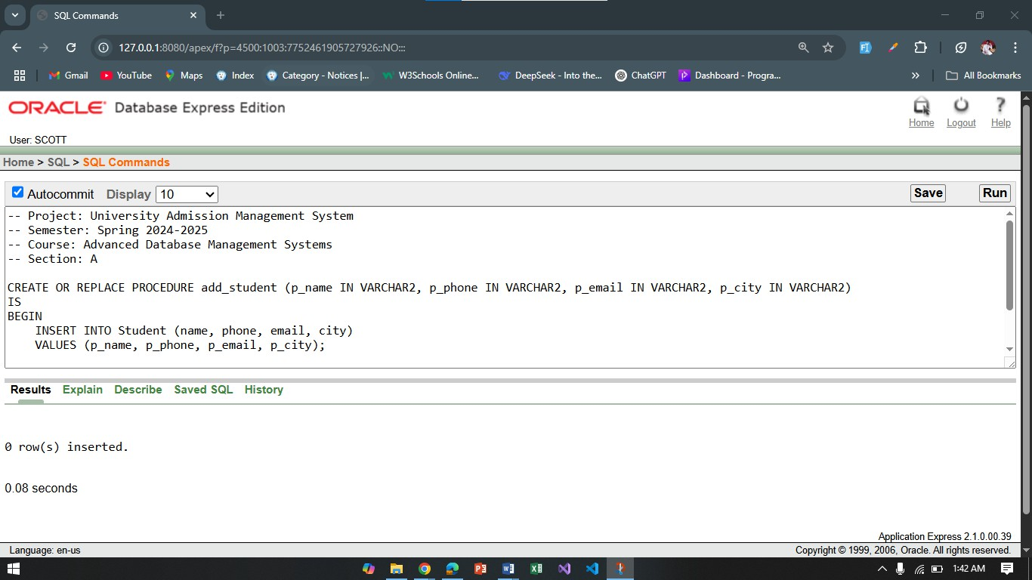

Table-Based Record
Question 1:
"Create a table-based record type to store student data and loop through it."
-- Project: University Admission Management System
-- Semester: Spring 2024-2025
-- Course: Advanced Database Management Systems

-- Section: A

DECLARE
TYPE student_record_type IS TABLE OF Student%ROWTYPE; v_students student_record_type;

BEGIN
SELECT * BULK COLLECT INTO v_students FROM Student;

FOR i IN 1..v_students.COUNT LOOP DBMS_OUTPUT.PUT_LINE('Student Name: ' || v_students(i).name);

END LOOP; END;
/
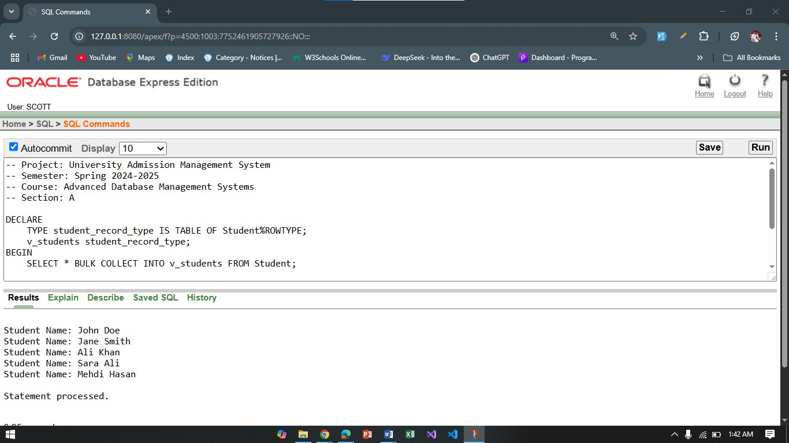

Question 2:
"Create a table-based record to collect test data and print test dates."
-- Project: University Admission Management System
-- Semester: Spring 2024-2025
-- Course: Advanced Database Management Systems
-- Section: A

DECLARE
TYPE test_record_type IS TABLE OF Test%ROWTYPE; v_tests test_record_type;

BEGIN
SELECT * BULK COLLECT INTO v_tests FROM Test;

FOR i IN 1..v_tests.COUNT LOOP

DBMS_OUTPUT.PUT_LINE('Test Date: ' || v_tests(i).test_date); END LOOP;

END;
/
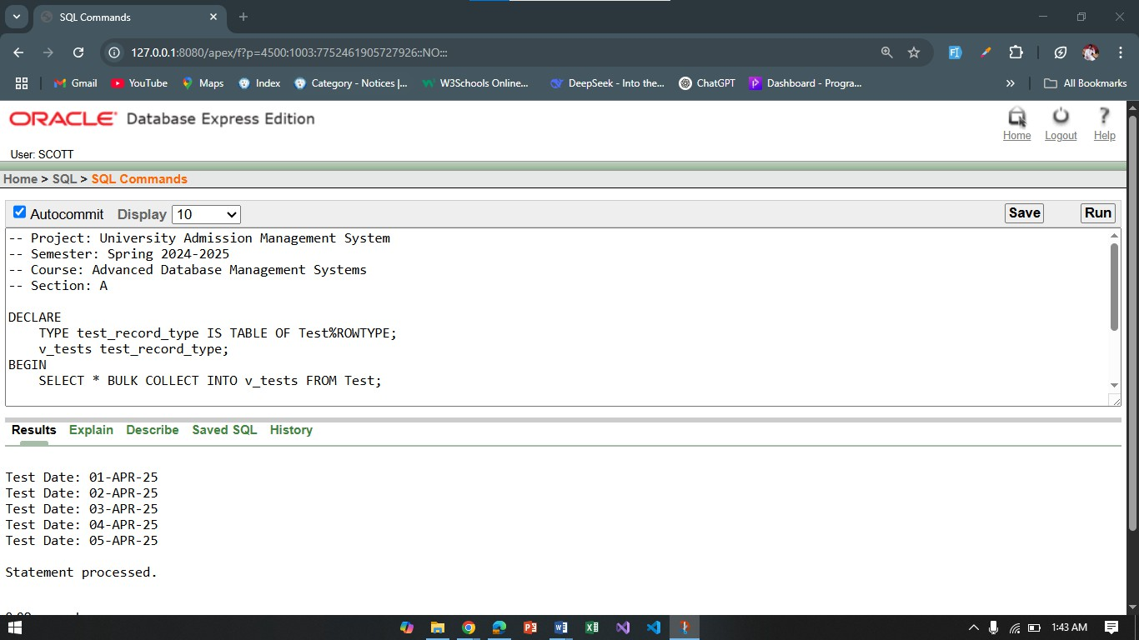

Explicit Cursor
Question 1:
"Create an explicit cursor to fetch students with their test scores."
-- Project: University Admission Management System
-- Semester: Spring 2024-2025
-- Course: Advanced Database Management Systems
-- Section: A

DECLARE
CURSOR c_students IS
SELECT s.student_id, t.total_marks FROM Student s
JOIN Test t ON s.student_id = t.student_id;

v_student c_students%ROWTYPE; BEGIN
OPEN c_students;

LOOP
FETCH c_students INTO v_student; EXIT WHEN c_students%NOTFOUND;
DBMS_OUTPUT.PUT_LINE('Student ID: ' || v_student.student_id || ', Total Marks: ' || v_student.total_marks);

END LOOP;

CLOSE c_students;

END;
/

Question 2:
"Create an explicit cursor to fetch students who passed the test."
-- Project: University Admission Management System
-- Semester: Spring 2024-2025
-- Course: Advanced Database Management Systems
-- Section: A

DECLARE
CURSOR c_passed_students IS SELECT s.student_id, t.total_marks FROM Student s
JOIN Test t ON s.student_id = t.student_id WHERE t.total_marks >= 50;

v_student c_passed_students%ROWTYPE; BEGIN
OPEN c_passed_students; LOOP
FETCH c_passed_students INTO v_student; EXIT WHEN c_passed_students%NOTFOUND;
DBMS_OUTPUT.PUT_LINE('Student ID: ' || v_student.student_id || ', Total Marks: ' || v_student.total_marks);

END LOOP;
CLOSE c_passed_students; END;
/

Cursor-Based Record
Question 1:
"Use a cursor-based record to print the names of students who passed the test."
-- Project: University Admission Management System
-- Semester: Spring 2024-2025
-- Course: Advanced Database Management Systems
-- Section: A

DECLARE
TYPE student_rec_type IS RECORD ( student_id NUMBER,
name VARCHAR2(100)

);
TYPE student_tab_type IS TABLE OF student_rec_type; v_students student_tab_type;

BEGIN
SELECT student_id, name
BULK COLLECT INTO v_students FROM Student
WHERE student_id IN (SELECT student_id FROM Test WHERE total_marks >= 50);

FOR i IN 1..v_students.COUNT LOOP DBMS_OUTPUT.PUT_LINE('Student Name: ' || v_students(i).name);

END LOOP; END;
/

Question 2:
"Fetch student names and display using cursor-based record."
-- Project: University Admission Management System
-- Semester: Spring 2024-2025
-- Course: Advanced Database Management Systems
-- Section: A

DECLARE
TYPE student_rec_type IS RECORD ( student_id NUMBER,
name VARCHAR2(100)
);
TYPE student_tab_type IS TABLE OF student_rec_type; v_students student_tab_type;

BEGIN
SELECT student_id, name
BULK COLLECT INTO v_students FROM Student;

FOR i IN 1..v_students.COUNT LOOP
DBMS_OUTPUT.PUT_LINE('Student ID: ' || v_students(i).student_id || ', Name: ' || v_students(i).name);

END LOOP; END;
/

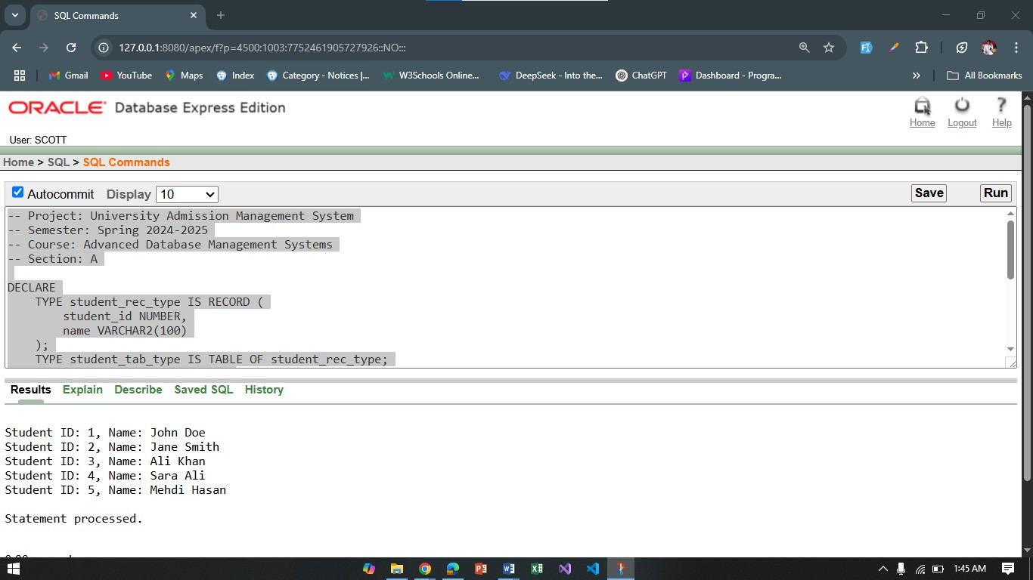

Row-Level Trigger
Question 1:
"Create a row-level trigger that updates the email to uppercase when a student record is inserted."
-- Project: University Admission Management System
-- Semester: Spring 2024-2025
-- Course: Advanced Database Management Systems
-- Section: A
CREATE OR REPLACE TRIGGER update_email_trigger BEFORE INSERT ON Student

FOR EACH ROW BEGIN
:NEW.email := UPPER(:NEW.email); END;

/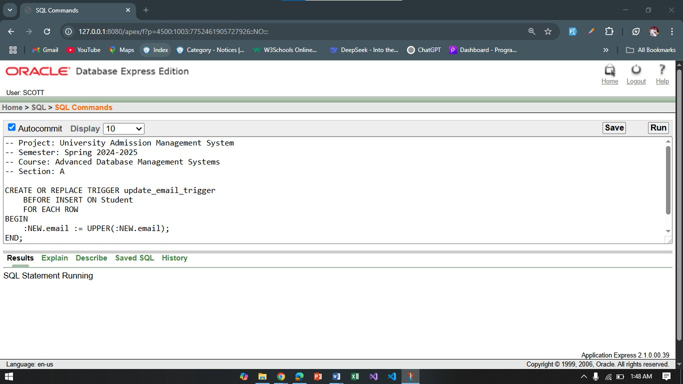 Question 2:
"Create a row-level trigger to log changes made to student names."

CREATE OR REPLACE TRIGGER log_student_name_changes BEFORE UPDATE ON Student

FOR EACH ROW BEGIN
INSERT INTO LogTable (log_message)
VALUES ('Student Name Changed from ' || :OLD.name || ' to ' || :NEW.name); END;
/

Statement-Level Trigger
Question 1:
"Create a statement-level trigger to log a message whenever a new student record is inserted."
-- Project: University Admission Management System
-- Semester: Spring 2024-2025
-- Course: Advanced Database Management Systems
-- Section: A

CREATE OR REPLACE TRIGGER log_student_insert AFTER INSERT ON Student

DECLARE
v_message VARCHAR2(100); BEGIN

v_message := 'New student added: ' || :NEW.name;
INSERT INTO LogTable (log_message) VALUES (v_message); END;
/
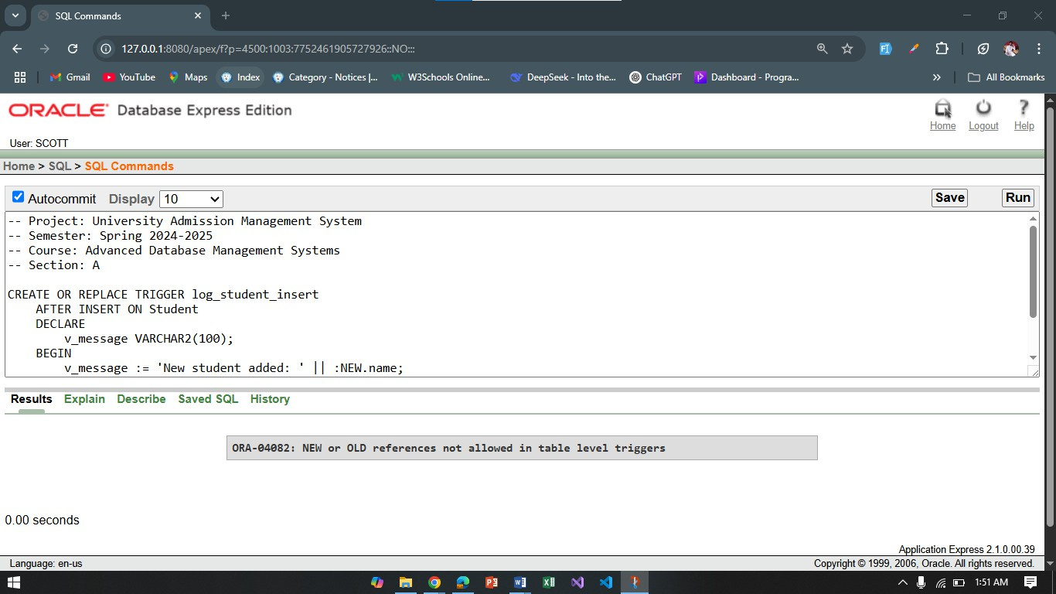

Question 2:
"Create a statement-level trigger to log a message after updating student records."
-- Project: University Admission Management System
-- Semester: Spring 2024-2025
-- Course: Advanced Database Management Systems
-- Section: A

CREATE OR REPLACE TRIGGER log_student_update AFTER UPDATE ON Student

DECLARE
v_message VARCHAR2(100); BEGIN
v_message := 'Student record updated: ' || :NEW.name;
INSERT INTO LogTable (log_message) VALUES (v_message); END;
/

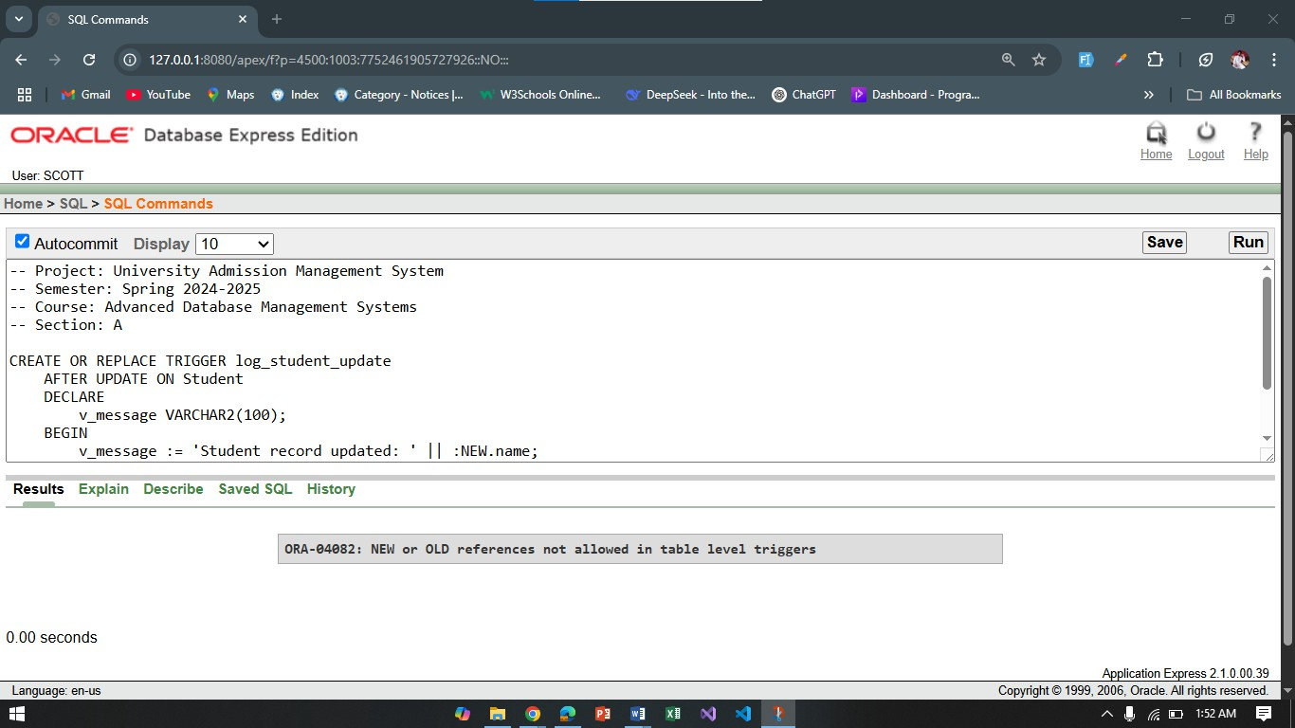

Package
Question 1:
"Create a package to manage student records, including procedures to add and update students."
-- Project: University Admission Management System
-- Semester: Spring 2024-2025
-- Course: Advanced Database Management Systems
-- Section: A

CREATE OR REPLACE PACKAGE student_pkg AS
PROCEDURE add_student(p_name VARCHAR2, p_phone VARCHAR2, p_email VARCHAR2); PROCEDURE update_student_status(p_student_id NUMBER, p_status VARCHAR2);
END student_pkg;
/

CREATE OR REPLACE PACKAGE BODY student_pkg AS
PROCEDURE add_student(p_name VARCHAR2, p_phone VARCHAR2, p_email VARCHAR2) IS BEGIN
INSERT INTO Student (name, phone, email) VALUES (p_name, p_phone, p_email); END add_student;

PROCEDURE update_student_status(p_student_id NUMBER, p_status VARCHAR2) IS BEGIN
UPDATE Application
SET result_status = p_status WHERE student_id = p_student_id;
END update_student_status; END student_pkg;

/
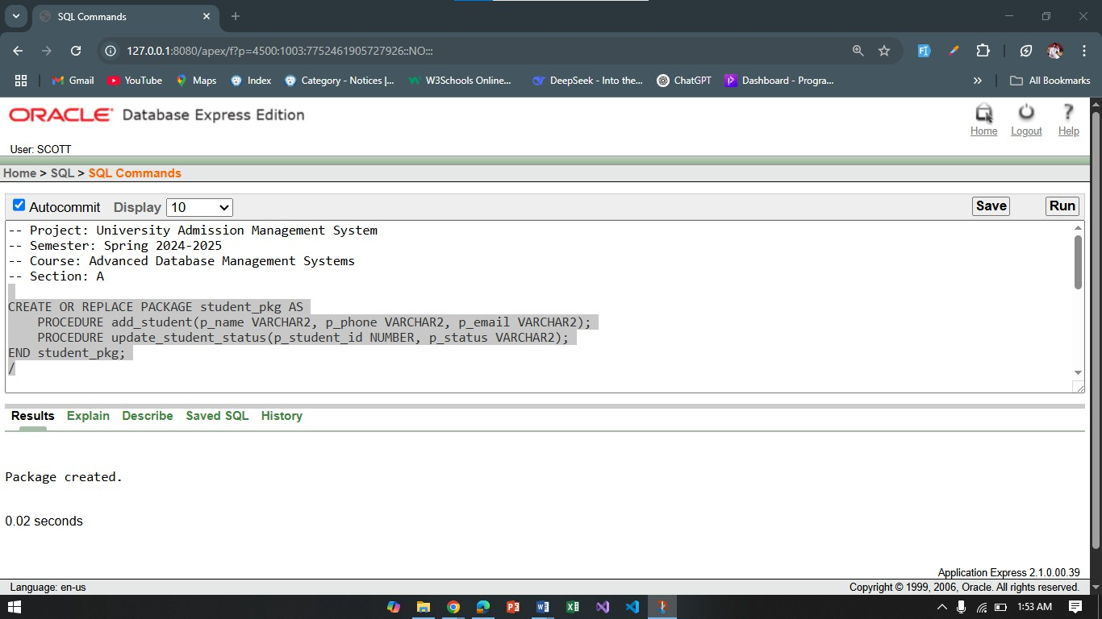

Question 2:
"Create a package to handle student test results and calculate their performance."
-- Project: University Admission Management System
-- Semester: Spring 2024-2025
-- Course: Advanced Database Management Systems
-- Section: A

CREATE OR REPLACE PACKAGE student_test_pkg AS
PROCEDURE add_test_result(p_student_id NUMBER, p_total_marks NUMBER); FUNCTION calculate_average(p_student_id NUMBER) RETURN NUMBER;
END student_test_pkg;
/

CREATE OR REPLACE PACKAGE BODY student_test_pkg AS
PROCEDURE add_test_result(p_student_id NUMBER, p_total_marks NUMBER) IS BEGIN
INSERT INTO Test (student_id, total_marks) VALUES (p_student_id, p_total_marks); END add_test_result;

FUNCTION calculate_average(p_student_id NUMBER) RETURN NUMBER IS v_avg NUMBER;

BEGIN
SELECT AVG(total_marks) INTO v_avg FROM Test WHERE student_id = p_student_id; RETURN v_avg;
END calculate_average; END student_test_pkg;

/
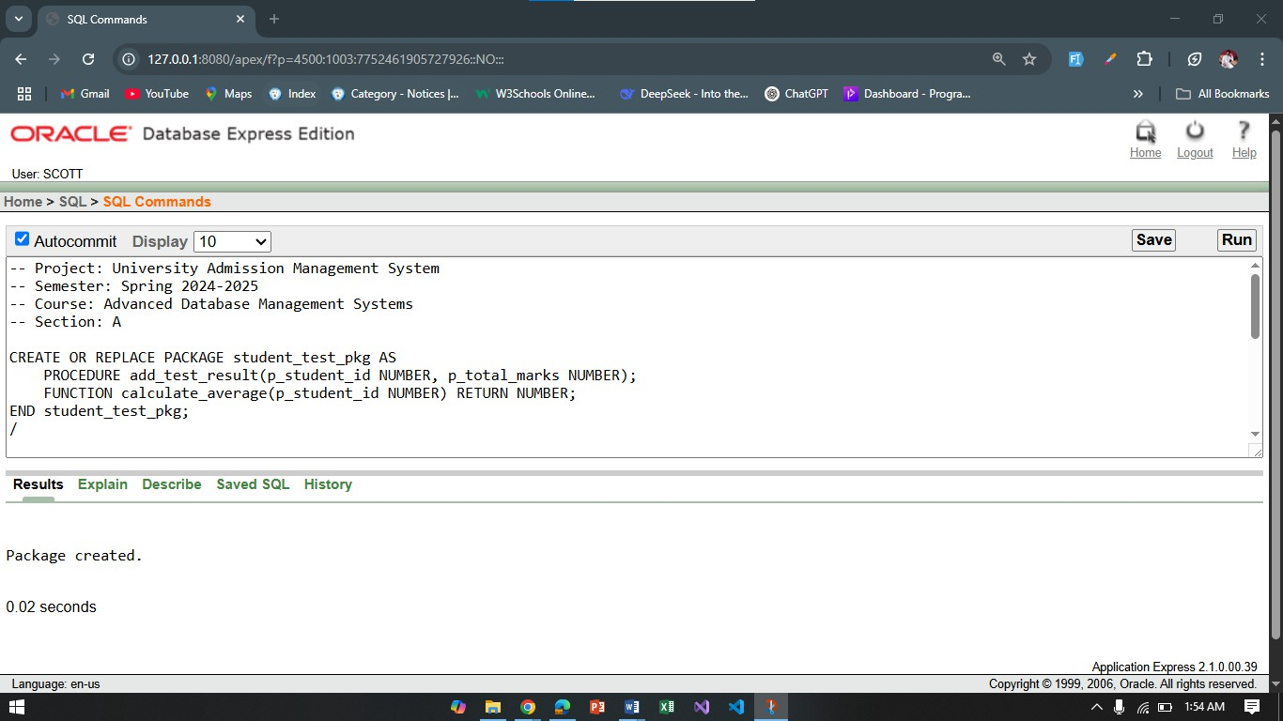

Conclusion:
The project successfully implements a robust DBMS for handling student data, applications, test results, and staff management, leveraging PL/SQL for advanced business logic. By integrating optimization techniques, improving user interface design, enhancing security, and exploring future integrations like machine learning or cloud computing, the system can evolve into a fully scalable, secure, and user-friendly application capable of meeting the growing needs of educational institutions.

